First Class
- Must meet 156 hours of clinical
- Midterm and exam usually online!!
- midterm - short answer scenario
- Must plan placement around exams**
- OSCES→ could be anything ** must say VITALS** working dx, full hx, focused exam, then diagnostic testings, differential

Learning plan due sept 25th
-- use the CNO new template, clearly state the principle in our goals**
-- code of conduct must be linked in the goals
-- use the template that is linked
-- submit to CRDB AND CANVA***
-- 4 goals
Do we need to submit 2 of them

Clinical logs
- WEEKLY*
- Rate level of responsibility
- Health concern/Dx can be general
- Every patient we have**
- Log hours weekly
- Last patient put total hours for the day** so it adds up for the total hours for that day*
- Must complete hours by OSCES

SOAP Notes+ Reflections **x3

Assignments due by midnight

To study
- Templates for diagnoses ** share templates
- Use notebook LM-- create audiobooks from textbooks
- Speechifiy

Create own template if needed.

Separate out the material

Diagnostic Reasoning Framework
- Establish the type of assessment. This will guide your health history and physical exam.
- Perform a focused health history using evidence-based research to identify the key features essential to formulating differential diagnoses.
- Formulate early diagnostic hypotheses (differential diagnoses). These may develop and change as you collect data during the health history and physical exam.
- Think of the Red Flags. This is part of the process when thinking of potential “dangerous” differential diagnoses that would require urgent management.
- Proceed with a review of system/s. This review has to be logical and short. For example you would not ask someone about headaches when the presentation is toe pain, but it would be appropriate for someone with diarrhea and vomiting. Use your judgement and critical thinking.
- Perform a systematic review. Consider epidemiological, social determinants of health, health promotion and risk factors for each condition. This process is fluid. While performing the complete health history, you will gather information that may trigger new potential differential diagnoses and you would have to ask the pertinent questions associated with these. Pay attention to the information you are collecting.
- Select the appropriate physical examination based on best evidence to rule in/rule out differential diagnoses.
- Integrate relevant history and physical examination findings into the diagnostic reasoning process.
- Apply evidence-based findings in the selection of appropriate screening tests, diagnostic investigations, and diagnostic imaging. Integrate the results of screening tests, diagnostic investigations and diagnostic imaging into the diagnostic plan.
- Formulate medical diagnoses in collaboration with the client, using evidence-informed diagnostic criteria, where appropriate. Discriminate between conditions within the scope of practice of NPs versus those conditions requiring referral for further investigation/treatment.
- Communicate the findings and diagnoses with the client.
- Consult with and/or refer to other health professionals as indicated.
Document history and physical assessment findings as well as the diagnosis(es) and diagnostic plan and follow-up in a timely, accurate and relevant manner.
Bayesian Reasoning= diagnostic reasoning
Module 1
The sensitivity of a test indicates the likelihood that it will be positive when disease is present
SnNout – when test with high sensitivity is Negative, it rules out the diagnosis of disease
The specificity of a test indicates the likelihood that it will be negative when disease is absent
SpPin – when test is highly Specific, a Positive result can rule in the diagnosis.

Important points
- Screening tools vs testing
- Prevalence and incidence
- Appraise literature to guide evidence based practice
- CNO- diagnosing, consulting ordering tests
- CNO standards, Entry to practice and standards**

Cultural safety and Humility
- based on respect
- Based on patients feeling of safety
- Self reflection to understand biases
- The patients NEEDS physical psychological, consent, medication, falls, pronouns **, sexuality, cultural

Assessment Types
Comprehensive assessment
- New patient intake visit
- Admission
- Try not to do a yearly physical anymore, does not lead to better health outcomes

Focused/problem orientation
- Specific concern or complaint
- Episodic
- Can be more than 1 system
- Medication management

Ongoing Monitoring
- Med management or chronic disease management

Preventative care
- Across all visits, scan the patient list to see what they are due for their screenings**
- Make a check list on preventative list
Education on WHY youre not doing an annual physical, and why youre doing or NOT doing a test
Choosing Wisely- is a guideline and for POPULATION health

- Try to implement ontario guidelines, then canadian then US guidelines (US seem to be a bit ahead)
- Primary prevention(reduce factors that lead to problems), secondary (early detection and intervention ie CA screening), tertiary (Tx after CA and prevent recurrence)

- Can do virtual care in clinical and document this in LOG
- Cant use AI as students, learn the SOAP note ect

Social determinants of health *** address in ASSIGNMENTS **
- Determinants of health and indigenous people
- Tree (core (ie institutional), stem (the person), root (laws, racisim ect))

Physical Exam
No matter what ASK ALL OF THESE QUESTIONS** (Especially OSCEs, say more*)
- OPQRSTU
- (Onset, provoking/palliating, quality (describe), radiating/relationship (ie headache is it related to anything), severity, timing (duration, frequency, time of day), Understanding the patients thoughts/ideas/feelings ** WHAT HAVE YOU TRIED**
- OLDCHARTS
- O- Onset (When did the symptom start? Was it sudden or gradual?)
- L - Location (Where exactly is the symptom or pain felt?)
- D - Duration (How long does it last? Is it constant or intermittent?)
- C - Character (What does it feel like? e.g., sharp, dull, burning, aching)
- H - History (Any pertinent medical history, habits, or risk factors)
- A - Aggravating factors (What makes the symptom worse?)
- R - Radiation / Relieving factors (Does the pain move anywhere? What makes it better?)
- T - Timing (What time of day is it worse? How frequently does it occur?)
- S - Severity (How bad is it on a scale of 1 to 10?) [1, 2, 3]
No matter what ASK ALL OF THESE QUESTIONS**
- ***PMHx,
- meds,
- Fam Hx,
- allergies,
- surgeries,
- vaccinations/immunizations,
- travel
- SOCIAL, drug benefits, partner, supports, housing*, abusive situation
- Substance use ** always say in OSCES
- Drug plan
- What have you tried? meds/therapies*

Working Dx first *
focused assessment* vitals always**
Then diagnosis **- be systematic*

- Documentation SOAP charting CNO standard doc.

Diagnostic Reasoning Framework
( chart) file:///Users/miranda/Downloads/diagnostic_framework%20(1).pdf
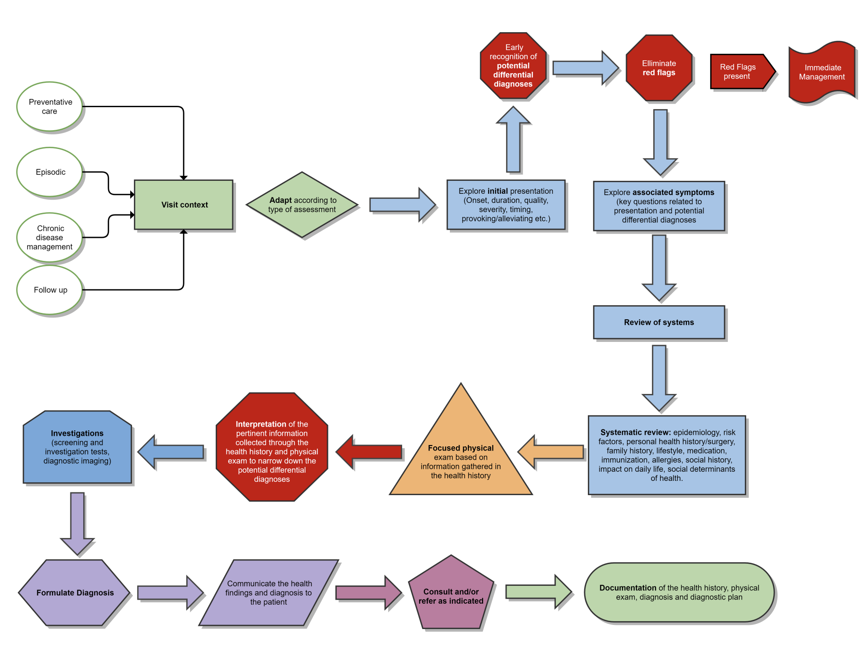

MAKE SURE TO BE SAFE, AND KNOW YOUR SCOPE OF PRACTICE**
If you dont know then ask*

Come up with 5 differential diagnosis (what diagnosis could the patient have that is causing the symptoms)

VINDICATE Mneumonic
V- vascular
I- infection/ inflamation
N- neoplasm
D- drugs/toxins, degenerate
I- iatrogenic, idiopathic
C- congenital/inherited, developmental
A- autoimmune, allergic, anatomic
T- trauma
E- endocrine, exposures

Case Studies
Case Study #1
Tom (he/him), a 34-year-old man, presents to the clinic after a two-year absence for a reported rash. The visit is scheduled for fifteen minutes; however, Tom arrives with a list of additional concerns he would like to discuss.
Questions — Case #1
1. How would you balance attending to Tom's concerns with the clinic’s scheduling constraints?
- Be clear on timing and why we cant address all of the concerns, and what is most pressing for Tom, then we can get him back to follow up with the other concerns
- Read written list if patient brought them, ask whats important for the patient
2. Discuss the benefits of identifying the type of health assessment most appropriate to the purpose of the encounter. What type of assessment is appropriate for Tom at this visit?
- focused/episodic assessment, Integumentary, pmhx, then next one would be more comprehensive

Case Study #2
Nellie (she/her), a 74-year-old Indigenous woman, presents to your clinic with her daughter. Nellie lives in a remote Indigenous community and is in the city visiting her daughter. In her home community, she normally receives sporadic, episodic care from an outpost nurse. Her daughter is requesting that Nellie be screened for cancer and diabetes. Nellie speaks very little English and tends to avoid eye contact when questioned.
Questions — Case #2
1. Discuss the process of adding Nellie as a new patient to your clinic.
- Would have to do an intake and comprehensive assessment on next visit
- Get record from outpost nurses
- See if shes had any screening done
- Get translator, can be better than family member
2. How can the NP provide culturally safe, sensitive care to Nellie and her daughter?
- Recognize and try to understand their cultural background
- Ask the patient/family, what approach is best just ASK
- Cant assume she is attached to her culture
- Do you practice any traditional healing?
- Do I have any biases ?
- Language barrier
3. How would you address the daughter's concerns about cancer and diabetes?
- Get the info* what are the specific concerns (is there a lump?)
- What has she had done in the past, get the records
- Ask NELLIE if she is concerned and get her perspective on her own care
- Whats the patients goals and whats
- Whats covered by OHIP, routine screening
Phone translator
Case Study #3
Karen (she/her), a 78-year-old widow, lives alone in a small, remote Indigenous community. She has had poorly controlled type 2 diabetes for fifteen years. Her two adult children have relocated to an urban area for better employment opportunities. A small, ulcerated area has been present on her right great toe for the past two months, which she has been treating herself. She can reach the nearby town for groceries, supplies, and clinic visits only when a friend can give her a ride. At her last clinic visit six months ago, the new NP suggested that Karen may need to begin insulin therapy to improve her blood glucose control. Karen is reluctant to do so because of the cost of the necessary supplies and a fear of self-injection. She reports that her monthly pension barely covers her groceries and utilities.
Question — Case #3
1. Based on the case presentation, discuss the social determinants of health that are affecting Karen's current health status.
- Income socioeconomic, geography, transportation, health literacy
- Access to supplies
- Whats her experience has she had with racism, colonization
- Trust in healthcare system

Pelvic Exams

•S” Subjective: important and relevant positives- and negatives from a focused hx’
•“O” Objective: important and relevant positive- and negative physical findings, test results.
•“A” Assessment: list of the differential diagnoses-in priority of most likely or important as determined from S and O.
•“P” Plan: list of tests or further diagnostic workup intended to narrow, confirm or evaluate dif dx. Should include only tests or work up warranted by S and O, and should be cost effective.
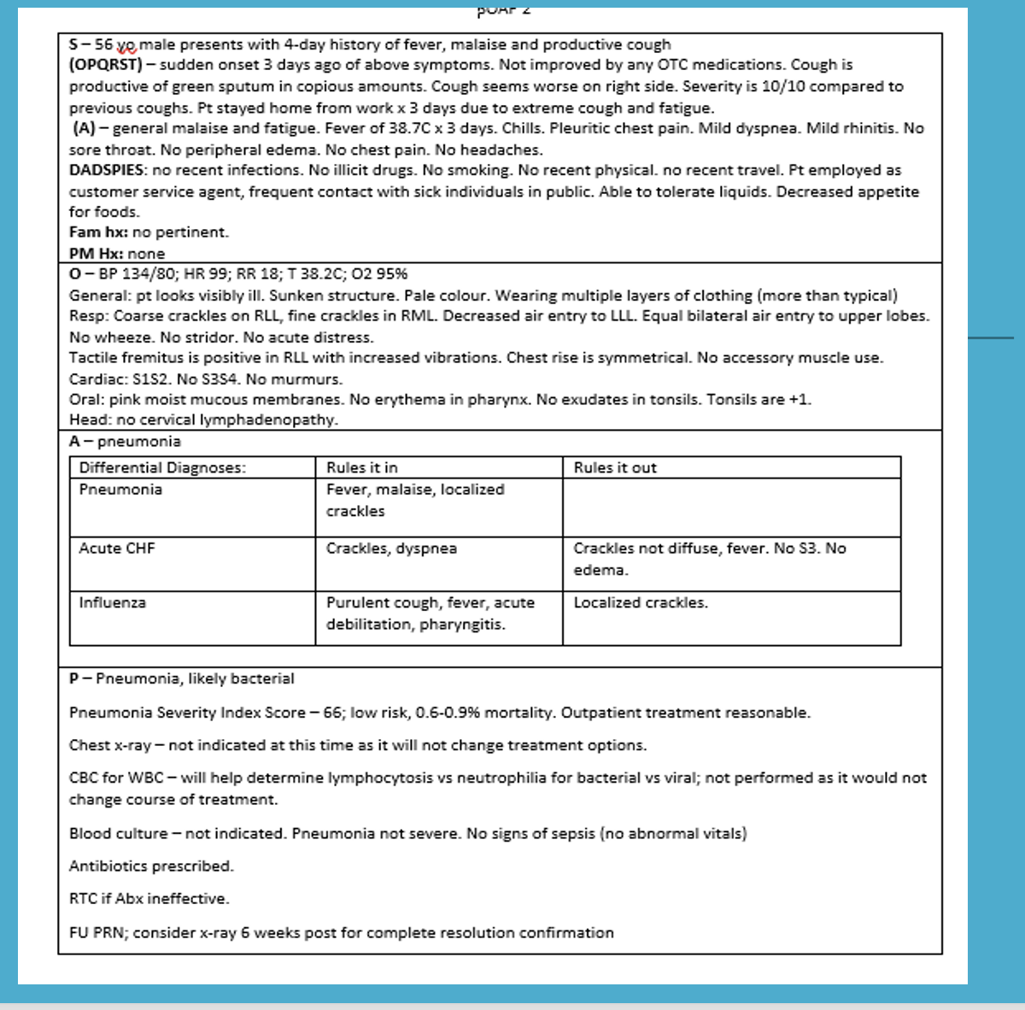
Common Diagnostic Errors

· Jumping to conclusions or being biased by an early finding (e.g., something in the past medical history or carried over from a previous visit) — anchoring bias.
· Accepting a diagnosis before fully verifying it and stopping the search too soon — premature closure.
· Accepting a previous diagnosis, label, or explanation without re-examining it (e.g., attributing chronic cough to "chronic bronchitis" in a patient on an ACE inhibitor) — diagnostic momentum.
· Seeking or interpreting evidence to support a favoured hypothesis while discounting evidence against it — confirmation bias.
· Judging a diagnosis as more likely simply because it comes readily to mind (recent or memorable cases) — availability bias.
· Over-weighting a "classic" pattern while ignoring how common or rare the condition actually is — representativeness / base-rate neglect.
· Stopping after the first plausible finding and missing a second, concurrent problem — search satisficing.
· Being unduly influenced by how the problem is framed by the patient or other clinicians — framing effect.
· Using a broad, unfocused ("shotgun") assessment without adequate focus or a working hypothesis.
· Focusing solely on the most obvious or likely explanation.
· Accepting the "horses" without contemplating the "zebras" — or pursuing "zebras" without first reasonably excluding more common conditions.
· Relying solely on memory, which limits the differential to what is recalled rather than systematically generated.
· Using the wrong rule, decision tree, algorithm, or guideline — or applying the correct tool incorrectly or outside its validated population.
· Performing assessment skills improperly.
· Misinterpreting, or relying on, inaccurate data (including unverified results carried forward from previous encounters).
· Ignoring basic but critical findings, such as vital signs or their trends.
· Allowing the patient to make the diagnosis (e.g., "I had sinusitis last year and this is exactly the same") without independent verification.
· Allowing other health care professionals to lead the diagnosis in the wrong direction (notes and handoffs can propagate error).
· Accommodating patient or family wishes against sound clinical judgement.
· Letting emotions, fatigue, time pressure, or feelings about a patient distort judgement — affective bias.
· Failing to consider medical conditions as the source of apparently "psychiatric" symptoms, and psychiatric conditions as the source of apparently "medical" presentations.
· Over-relying on fast, intuitive (Type 1) reasoning without engaging slower, analytical (Type 2) reasoning to cross-check the working diagnosis.
· Overlooking system contributors — time pressure, workload, fragmented information, and failures in test-result follow-up or team communication — that increase diagnostic risk.

References: Goolsby, M. J., & Grubbs, L. (2022). Advanced assessment: Interpreting findings and formulating differential diagnoses (5th ed.). F. A. Davis. · National Academies of Sciences, Engineering, and Medicine. (2015). Improving diagnosis in health care. · Croskerry, P. (2003). Academic Medicine, 78(8), 775–780. · Croskerry, P., Singhal, G., & Mamede, S. (2013). Cognitive debiasing 1 & 2. BMJ Quality & Safety, 22(Suppl 2).

1. Diagnostic Reasoning: The Big Picture
Diagnostic reasoning is the process of forming and revising possible diagnoses as new clinical information becomes available. Bayesian reasoning describes the same idea in probability terms: each new finding raises or lowers the likelihood of a diagnosis.
Core principle: diagnosis is not linear. If the clinical picture does not fit, reassess the working diagnosis and the differential.
Case Study: Skin Lesion
Initial differential: Malignant (melanoma, SCC, BCC) vs non-malignant (seborrheic keratosis, dermatofibroma).
Findings that increased concern: >6 mm, raised/rolled borders, recent growth, colour change, personal history of BCC.
What the exam could do: Increase suspicion, but not confirm malignancy.
Definitive evidence: Biopsy showed an inflamed seborrheic keratosis.
Reasoning lesson: New evidence can change the probability and final diagnosis, even when the initial pattern appears concerning.

System 1 vs System 2 Thinking
System 1 | System 2
Fast, automatic, intuitive; uses pattern recognition. Efficient but more prone to bias/error. | Slower, deliberate, analytical; useful when the case is atypical, prolonged, complex, or does not fit expectations.
Example: typical 3-day sore throat with fever, no cough, cervical nodes, positive rapid strep → strep pharyngitis. | Example: 4-week sore throat + high-risk sexual activity + exudate → broader testing; gonorrhea swab positive → gonococcal pharyngitis.

Use both systems interchangeably. The skill is recognizing when a “straightforward” pattern needs slower System 2 analysis.

2. Build and Organize the Differential
Choose a framework that fits the complaint, then sort diagnoses by clinical priority.
Framework | How to use it | Example
Mechanism | Group causes by pathophysiologic mechanism. | Sore throat: infectious (viral, bacterial, fungal) vs non-infectious (GERD, allergies, irritants, trauma); broaden to hematologic/malignant in atypical cases.
Systems | Generate causes by organ system. | Acute dyspnea: respiratory, cardiac, renal, hematologic.
Anatomic | Generate causes by structures in the symptomatic region. | Pelvic pain: ovarian, uterine, vaginal, cervical, pregnancy-related, appendix/bowel.

Then organize into 3 buckets
Most likely | Less likely | Must not miss
Best fits current evidence. | Still plausible, but less supported. | Serious diagnosis that requires consideration even if probability is lower.

Case Study: Acute Dyspnea
Most likely: Pneumonia — fever, fatigue, cough, 38°C, tachycardia, LLL crackles.
Less likely: Heart failure, kidney failure, anemia, arrhythmia.
Must not miss: PE, ACS, anaphylaxis. Evidence against these included low Wells score/no leg swelling or hemoptysis, no chest pain, and no angioedema/hives.

Case Study: Pelvic Pain
Presentation: Missed LMP, spotting x1 week, acute pelvic/abdominal pain; LLQ tenderness with rebound and scant cervical bleeding.
Most likely: Ectopic pregnancy or miscarriage.
Less likely: Cervicitis, PID, endometriosis, fibroids, GI pathology.
Must not miss: Ectopic pregnancy and PID.
Reasoning lesson: A diagnosis can be both “most likely” and “must not miss.”

3. Pre-Test Probability and Deciding Whether to Test
Pre-test probability = the likelihood of disease before the diagnostic test is performed. Estimate it as low, intermediate, or high. It guides whether to test, which test to use, and how much weight to give the result.

Before ordering a test, ask 5 questions
1. What is the probability of the disease: low, intermediate, or high?
2. Have I reached the treatment threshold?
3. Will the test change my management?
4. Could testing cause more harm than good?
5. What will I do with a positive result? What will I do with a negative result?
Treatment threshold = the point at which disease probability is high enough that treatment is appropriate without further diagnostic confirmation.
Case Study: Uncomplicated UTI
Presentation: 3 days dysuria + urinary frequency; no complicating factors or systemic features.
POCT urinalysis: Positive nitrites and leukocytes.
Pre-test probability: High.
Treatment threshold: Reached.
Testing lesson: In the uncomplicated example from the slides, additional testing was unlikely to change management.

What counts as a diagnostic test?
Any information that increases or decreases disease probability can function diagnostically: history questions, physical examination findings, laboratory tests, imaging, pulmonary function testing, biopsy, and other procedures.

4. Test Performance: Sensitivity and Specificity
Concept | Definition | Error pattern | High-yield interpretation
Sensitivity | Correctly identifies patients who HAVE disease. | Low sensitivity → more false negatives. | High sensitivity + negative result helps rule OUT (SNOUT).
Specificity | Correctly identifies patients who are disease-free. | Low specificity → more false positives. | High specificity + positive result helps rule IN (SPIN).
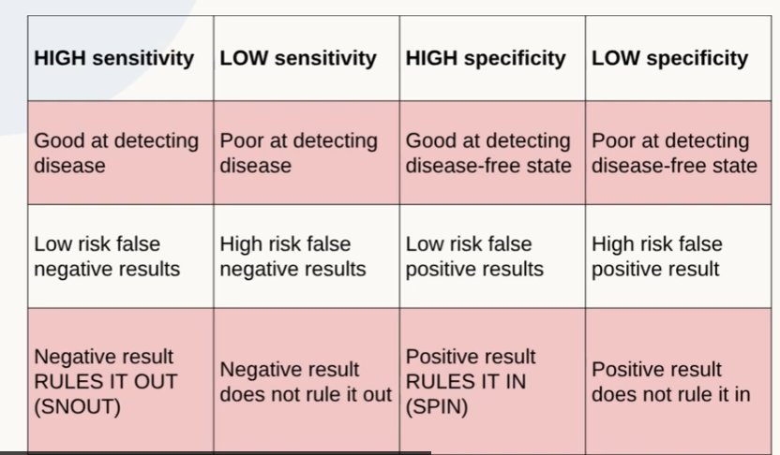

Four possible test outcomes
Disease status | Test + | Test −
Disease present | True positive | False negative
Disease absent | False positive | True negative

Interpret sensitivity/specificity in the clinical context and against pre-test probability; a test result changes probability rather than replacing reasoning.

Clinical Application Cases
ANA and Lupus
Presentation: Malar rash, fatigue, joint swelling; pre-test probability intermediate.
Threshold: Not yet at treatment threshold; testing could change management.
Test characteristics in the slides: ANA = high sensitivity, low specificity.
Interpretation: A negative result is more useful for lowering the probability of lupus; a positive result does not by itself confirm disease.
Slide outcome: ANA 1:160 positive → rheumatology referral.

Chest X-Ray and Lung Malignancy
Presentation: Chronic cough + unintentional weight loss; pre-test probability intermediate.
Test characteristics in the slides: Chest x-ray = high specificity, low sensitivity.
Interpretation: If a mass is seen, it is more likely to be a true finding; a clear x-ray may still miss lung malignancy.

Nitrites and UTI
Presentation: Dysuria, positive nitrites, no complicating factors; probability of UTI high.
Test characteristics in the slides: Nitrites = low sensitivity, high specificity.
Interpretation: Negative nitrites do not rule out UTI; positive nitrites strongly support UTI.

5. One Clinical Reasoning Sequence to Memorize
1. Identify the presenting problem.
2. Choose a framework: mechanism, systems, or anatomic.
3. Generate the differential and sort into most likely / less likely / must not miss.
4. Estimate pre-test probability.
5. Use history + exam findings to update probability.
6. Ask whether the treatment threshold has been reached.
7. If testing is needed, ask whether it will change management and what +/− results would mean.
8. Interpret the result using sensitivity/specificity and clinical context.
9. Update the differential; move between System 1 and System 2 as needed.

High-Yield Memory Box
• Bayesian reasoning: new evidence continually raises or lowers diagnostic probability.
• System 1: fast/pattern-based. System 2: slower/analytical.
• Pre-test probability comes BEFORE the test.
• SNOUT: highly Sensitive test + Negative result helps rule OUT.
• SPIN: highly Specific test + Positive result helps rule IN.
• Before testing: probability → treatment threshold → change management? → harm? → what will I do with +/−?
• Differential: most likely / less likely / must not miss.
Source basis: Vicky Sanderson, NP — NP Reasoning slide decks on Bayesian reasoning & systems of thinking, pre-test probability, case summarization, and diagnostic testing introductory concepts.

NURSE PRACTITIONER
Roles, Legal Responsibilities & Comparison With the RN
High-level study guide | Ontario | Jot-point format

Core idea
• An NP is an RN in the Extended Class with additional education, experience and examination requirements.
• NP scope adds autonomous diagnostic, test-ordering and therapeutic authority to the nursing foundation.
• Effective July 1, 2026, Ontario moved to one NP classification rather than population-specific NP certificates.
• Both RNs and NPs remain individually accountable for legal authority, practice context and personal competence.

1 | NP ROLE: WHAT THE NP IS RESPONSIBLE FOR

Advanced health assessment | • Perform comprehensive or focused assessment based on the clinical presentation.  • Integrate history, physical exam, procedures and relevant data.  • Identify urgent, emergent and life-threatening conditions.
Diagnosis | • Generate and narrow differential diagnoses.  • Establish probable diagnoses using assessment findings and diagnostic data.  • Communicate diagnoses and explain relevant findings, prognosis and treatment implications.
Diagnostics | • Order appropriate diagnostic tests within legal scope and competence.  • Interpret results and integrate findings into clinical decision-making.  • Ensure reliable follow-up systems for results and timely communication of clinically significant findings.
Therapeutic management | • Create and document an evidence-informed plan of care with the client.  • Select treatments, interventions and procedures.  • Stabilize clients in urgent or life-threatening situations.
Pharmacotherapy | • Select medication based on diagnosis, evidence, determinants of health and client preferences.  • Write legally complete prescriptions.  • Counsel on rationale, cost, adverse effects, interactions, contraindications, precautions and adherence.  • Monitor response and continue, adjust or discontinue therapy as clinically indicated.
Collaboration / referral | • Consult or refer when needs exceed legal scope, individual competence or available resources.  • Integrate recommendations from other providers into the plan of care.  • Clarify orders and care plans for other team members.

2 | NP LEGAL RESPONSIBILITIES: HIGH-YIELD POINTS

Legal framework / protected title
• Practice under the Regulated Health Professions Act, 1991, Nursing Act, 1991, regulations and CNO standards.
• Only nurses registered with CNO in the Extended Class may use the protected title “Nurse Practitioner” or “NP”.
• Employer policy may restrict practice but cannot expand the legislated NP scope.
Authority + context + competence
• Before performing an activity: confirm legal authority, setting supports it, and you have the knowledge, skill and judgment to manage possible outcomes.
• Do not perform an activity simply because it is within the profession’s scope if it is outside your individual competence.
Client assessment / diagnosis
• Use appropriate assessment to support the diagnosis and plan.
• Communicate diagnoses and clinically significant results clearly.
• Verify that the client understands relevant findings and the diagnosis.
Test-result responsibility
• Arrange appropriate follow-up for ordered tests.
• Use or advocate for reliable systems so results are received and communicated in a timely manner.
• Act on clinically significant or urgent results.
Prescribing / medications
• Prescribe, dispense, compound or sell medication only for therapeutic purposes within a professional relationship.
• Maintain an accurate medication history and assess contraindications, interactions, monitoring needs and follow-up.
• Prescription must include required client, drug, dose/route/frequency, prescriber, date, signature and refill information.
Controlled substances
• Prescribing authority requires CNO-approved controlled-substance education.
• Use evidence-informed risk assessment for misuse, addiction and diversion.
• Prescribe quantities that balance clinical need, reassessment and risk of harm.
• Under federal law, NPs are not authorized to prescribe opium or coca leaves.
• Do not authorize directives for controlled substances.
Conflict of interest / boundaries
• Do not prescribe medication to yourself.
• Professional services to family, partners, friends or acquaintances are limited to circumstances permitted by CNO boundary standards.
• Controlled substances for family/friends are restricted to emergencies when no other prescriber is immediately available.
• Do not allow personal or industry benefit to interfere with evidence-informed clinical judgment.
Discontinuing care
• Do not abruptly end necessary services.
• If care is discontinued, arrange alternate/replacement services or provide a reasonable opportunity to obtain them.
• Continue essential care when feasible until another provider is identified.
• Document the reasons and steps taken.
NP controlled acts: 8 categories
• Communicate an NP-made diagnosis.
• Perform a procedure below the dermis or a mucous membrane.
• Insert an instrument, hand or finger beyond specified body openings.
• Apply or order the application of a specified form of energy.
• Set or cast a fracture or joint dislocation.
• Administer a substance by injection or inhalation.
• Prescribe, dispense, sell or compound medication.
• Perform the controlled act of psychotherapy for a serious disorder within a therapeutic relationship.

NP controlled acts that CANNOT be delegated
• Prescribing, dispensing, selling or compounding medication.
• Ordering the application of a form of energy.
• Setting a fracture or joint dislocation.
• The controlled act of psychotherapy for a serious disorder.

3 | NP vs. RN: SCOPE & LEGAL AUTHORITY AT A GLANCE

Area | NP | RN
Registration | • RN in CNO Extended Class.  • Additional NP education, experience and exam requirements. | • RN in CNO General Class.  • RN prescribing is an additional authorization, not standard entry-level RN authority.
Primary clinical role | • Assess, diagnose, order/interpret tests, treat, prescribe and follow through. | • Assess, monitor, provide nursing care and implement treatments/orders within RN authority.
Assessment | • Comprehensive / focused advanced assessment to support diagnosis and treatment. | • Comprehensive nursing assessment and clinical judgment within RN role.
Diagnosis | • May independently make and communicate diagnoses within competence. | • General RN: no broad authority to communicate a medical diagnosis as a controlled act.  • RN prescriber: may communicate a diagnosis only for the purpose of prescribing an authorized medication.
Diagnostic tests | • May order and interpret authorized diagnostic tests. | • No general independent RN authority to order diagnostic tests.  • Often acts under orders, directives and setting-specific mechanisms.
Prescribing | • Broad prescribing authority within legal scope, competence and restrictions. | • General RN: does not prescribe.  • RN with CNO prescribing authority: may prescribe only medications/categories authorized by regulation and CNO requirements.
Controlled acts | • 8 controlled-act categories plus other authorized activities. | • 5 controlled acts, generally when ordered or when RN initiation conditions are met.  • RN prescribers have two additional controlled acts tied to prescribing.
Orders / directives | • May issue orders within NP authority.  • May authorize directives, subject to restrictions. | • Usually receives orders/directives for controlled acts.  • Can initiate specific controlled acts in defined circumstances and settings.
Autonomy | • Autonomous provider, accountable for own diagnostic and therapeutic decisions. | • Independent nursing judgment within RN scope, but many medical treatments/controlled acts require an authorizing mechanism.
Follow-up responsibility | • Direct responsibility for tests ordered, diagnosis, treatment response, medication monitoring and referral. | • Responsible for assessment, monitoring, recognizing change, evaluating care and escalating/communicating as required.
Referral / consultation | • Consult or refer when beyond NP scope/competence or when another provider’s expertise benefits the client. | • Escalate, consult or transfer care when client needs exceed RN authority, competence or setting resources.

Simplest way to remember the difference
• RN: assess + recognize + provide nursing care + implement/monitor treatment + escalate.
• NP: assess + diagnose + order/interpret diagnostics + treat/prescribe + monitor + refer.
• Both: must have authority, appropriate context and personal competence before performing an activity.

4 | LEGAL / EXAM PEARLS

• Scope is not the same as competence. Being legally authorized does not mean every NP is individually competent to perform every activity.
• Employer policy cannot enlarge scope. An organization can limit what you do, but cannot grant legal authority that legislation does not provide.
• Ordering creates follow-up responsibility. If you order a test, you need a reliable process to receive, review, communicate and act on the result.
• A diagnosis creates communication responsibilities. Explain clinically relevant information, treatment implications, expected outcomes and confirm understanding.
• Prescribing includes monitoring. The responsibility is not finished when the prescription is written. Reassess response, adverse effects, adherence and need for continuation/change.
• Consultation is part of safe autonomous practice. Autonomy does not mean practising in isolation. Refer when needs exceed scope, competence or available resources.
• Verbal orders are limited. NP verbal orders should be used only when the NP cannot immediately document the order and should be signed as soon as possible.
• Controlled substances have extra safeguards. Assess misuse/addiction/diversion risk, provide education and arrange ongoing monitoring.

NP ENTRY-LEVEL COMPETENCIES
High-yield study guide | 29 competencies across 5 roles
Jot points only • Focused on what an entry-level NP must be able to do

Big picture
• Entry-level NP competencies build on RN competencies and remain expectations throughout an NP’s career.
• Entry-level NPs practise autonomously within legislation, standards, ethics and scope, while seeking guidance when a situation exceeds individual competence.
• All roles are interconnected: Clinician, Leader, Advocate, Educator and Scholar.
• Evidence use, critical thinking, compassion, ethics and care across the lifespan apply throughout the framework.

1 | FRAMEWORK AT A GLANCE

Role | Count | Main focus
1. Clinician | 16 competencies | Assessment, diagnosis, management, prescribing, procedures, counselling, harm reduction, transitions, documentation, self-employment, virtual care
2. Leader | 3 competencies | Teams, quality/safety, health promotion & disease prevention
3. Advocate | 6 competencies | Bias, equity, cultural safety, Indigenous care, access, policy
4. Educator | 2 competencies | Develop education + evaluate learning
5. Scholar | 2 competencies | Research + knowledge translation

2 | ROLE 1: CLINICIAN

Clinician = the core advanced-practice role
• Deliver safe, competent, compassionate and ethical care across the lifespan.
• Use evidence-informed practice, advanced diagnostic reasoning and critical inquiry.
• Move through the full clinical cycle: assess → diagnose → manage → monitor → modify → refer.

1.1 Establish reason for encounter | • Initial observation of condition.  • Clarify presenting concerns with focused questions.  • Evaluate relevant information.  • Prioritize routine, urgent, emergent and life-threatening situations.
1.2 Obtain informed consent | • Clarify services, expectations, priorities, strengths and limitations.  • Discuss risks, benefits, alternatives and consequences.  • Obtain consent for collection, use and disclosure of health information.
1.3 Analyze/synthesize multiple sources | • Integrate biopsychosocial, behavioural, cultural, developmental and social determinants of health.  • Use past/current history, investigations and credible evidence.  • Collect full pharmacological history including OTC, natural, traditional and complementary therapies.  • Support advance care planning and palliative/end-of-life wishes.
1.4 Conduct relevant assessment | • Choose focused vs comprehensive assessment.  • Use valid/reliable tools and techniques.  • Include ROS and mental-health assessment when indicated.  • Order/perform screening, diagnostic and point-of-care tests using resource stewardship.
1.5 Formulate diagnoses | • Interpret investigation results.  • Generate differential diagnoses.  • Determine leading/final diagnosis using clinical and diagnostic reasoning.  • Explain findings, diagnosis, prognosis and anticipated outcomes.
1.6 Create shared management plan | • Explore management options with the client.  • Consider cost, access, determinants of health, efficacy and adherence.  • Prioritize interventions by client goals, resources and urgency.  • Consult other professionals; use virtual care/EHR/tracking systems appropriately.
1.7 Prescribe & counsel | • Follow legislation, regulation and organizational requirements.  • Choose evidence-informed pharmacologic therapy based on diagnosis, concurrent therapies and medication history.  • Use monitoring/reporting systems; complete medication reconciliation.  • Identify polypharmacy; deprescribe when possible.  • Use pharmacological stewardship and establish monitoring/follow-up.  • Counsel on indication, benefit, cost, adverse effects, interactions, contraindications, precautions and adherence.
1.8 Perform interventions | • Explain indication, risks/benefits, aftercare and follow-up.  • Use evidence-informed technique for invasive/non-invasive procedures.  • Monitor outcomes and aftercare.  • Stabilize urgent, emergent and life-threatening conditions.
1.9 Evaluate management plan | • Use a systematic, timely follow-up process.  • Evaluate response and revise/stop treatment as needed.  • Facilitate continuity with client, family, team and community partners.  • Refer when client would benefit or needs exceed NP scope/competence.
1.10 Build therapeutic counselling relationship | • Clarify goals, expectations, priorities and barriers.  • Use culturally and developmentally relevant communication.  • Evaluate effectiveness and refer when needed.
1.11 Provide counselling interventions | • Apply lifespan development principles and therapeutic use of self.  • Recognize bias and create safe spaces.  • Respond safely to intense emotion.  • Provide trauma- and violence-informed care.  • Recognize intergenerational trauma and manage transference/countertransference.
1.12 Harm reduction / substance use | • Identify risks and signs of substance use disorder.  • Co-create harm-reduction plan.  • Use evidence-informed, safe prescribing.  • Follow legal/policy requirements for controlled drugs and substances.  • Teach safe storage and handling.
1.13 Lead transitions of care | • Lead admission, transfer and discharge planning.  • Ensure access to resources, medications, diagnostics, procedures and follow-up.  • Transfer information and connect to community/system resources.  • Modify plan according to transition needs.
1.14 Record keeping | • Document all encounters and rationale for actions.  • Manage collection/use/disclosure/destruction of health information appropriately.  • Apply privacy, confidentiality and record-security requirements.
1.15 Self-employed practice | • Follow legal, regulatory and ethical requirements.  • Use honest billing and advertising.  • Protect client information as health information custodian.  • Identify/manage conflicts of interest; act in client’s best interest.
1.16 Virtual care | • Explain risks/benefits and obtain consent.  • Maintain privacy and secure electronic transfer.  • Decide when virtual care is appropriate vs in-person.  • Adapt history/assessment and communication to virtual format.  • Meet documentation and communication requirements.

3 | ROLE 2: LEADER

2.1 Lead within the health system
• Build interprofessional, intraprofessional and intersectoral partnerships.
• Use situational awareness to analyze team/organizational functioning.
• Promote transparent communication, trust, teamwork and conflict resolution.
• Support, direct, educate and mentor others.
• Use environmental, financial and resource stewardship.
2.2 Improve quality, safety & excellence
• Scan environment for future client/system needs.
• Lead/participate in quality and risk-management initiatives.
• Use benchmarks and best practices to set improvement goals.
• Collect/track QI data and recommend changes.
• Communicate outcomes and respond to complex/unpredictable situations.
• Advocate for safe and healthy practice environments.
2.3 Health promotion & disease prevention
• Monitor public/population health trends.
• Design programs using data, evidence and identified needs.
• Use informatics for surveillance.
• Lead primary, secondary and tertiary prevention strategies.
• Promote awareness of social determinants of health and public-health resources.
• Support disaster/pandemic planning and evaluate programs.
4 | ROLE 3: ADVOCATE

3.1 Minimize personal bias
• Use cultural humility and examine assumptions, beliefs, privilege and stereotypes.
• Recognize effects of unequal power/resources.
• Use respectful dialogue and shared decision-making.
• Seek feedback on own behaviour.
3.2 Create diverse, equitable, inclusive & culturally safe practice
• Recognize unique experiences of discrimination/oppression.
• Respect culture, lived experience, gender identity, sexuality and expression.
• Address racist/discriminatory behaviour.
• Integrate the client’s view of health/healing and involve important persons/communities.
• Collaborate with interpreters, leaders and local partners.
3.3 Culturally safe, anti-racist care for Indigenous Peoples
• Recognize historical/ongoing effects of colonialism and systemic oppression.
• Respect diverse Indigenous languages, histories, healing practices and ways of knowing.
• Use cultural humility and self-determination.
• Make space for lived experience and client-defined needs/goals.
• Facilitate access to Elders, Knowledge Keepers, cultural navigators, interpreters and family when requested.
• Seek feedback on own behaviour.
3.4 Promote equitable care
• Navigate systemic barriers to access.
• Challenge bias, systemic oppression and inequitable structures.
• Respond to social, structural, political and ecological determinants of health.
• Address inequity within own sphere of influence.
3.5 Advocate for access & system change
• Support anti-racism and anti-oppression education/resources.
• Advocate for policies and environments that improve equitable access.
• Identify bias/limitations in systems and information.
• Raise client awareness of the right to quality care.
3.6 Influence policy & legislation
• Understand the relationship between policy and practice.
• Recommend evidence-informed policy changes.
• Evaluate policy/legislation effects on health and equity.
• Communicate evidence concisely and contribute to policy/legislation development.
5 | ROLE 4: EDUCATOR

4.1 Develop & provide education
• Use teaching/learning theory to develop, deliver, modify and evaluate education.
• Create evidence-informed materials and programs.
• Use technology to enhance learning.
• Mentor others to build educational capacity.
4.2 Evaluate learning
• Use evaluation tools to measure knowledge acquisition.
• Analyze evaluation data and modify content/delivery.
• Coach others to improve educational materials and outcomes.
6 | ROLE 5: SCHOLAR

5.1 Contribute to research
• Build collaborative research relationships.
• Connect research with advanced practice and identify knowledge gaps.
• Follow ethical research principles, including First Nations OCAP principles.
• Use valid/reliable methodologies and analyze findings appropriately.
5.2 Translate knowledge into practice
• Explain practical applications of research.
• Identify where evidence can be integrated into practice.
• Share findings with clients, teams, communities and organizations.
• Use evidence to develop standards, guidelines, practices and policies.
• Lead implementation and model evidence-informed practice.
7 | HIGH-YIELD MEMORY MAP

Think: NP = Clinical care + systems thinking + equity + teaching + evidence
• CLINICIAN: assess, diagnose, manage, prescribe, perform procedures, monitor, counsel, transition, document.
• LEADER: build teams, improve systems, lead QI/safety, promote health and prevention.
• ADVOCATE: examine bias, promote equity, provide culturally safe care, remove barriers, influence policy.
• EDUCATOR: teach effectively and evaluate whether learning occurred.
• SCHOLAR: contribute to research and move evidence into practice.

Entry-level NP habits that appear across the whole document
• Co-create care with the client rather than simply directing it.
• Use evidence + critical thinking + clinical reasoning.
• Consider social determinants, culture, cost, access and feasibility.
• Know limits and consult/refer when beyond individual competence or scope.
• Document rationale, monitor outcomes and ensure continuity/follow-up.
• Use technology appropriately while protecting privacy and confidentiality.

8 | KEY TERMS WORTH KNOWING

Co-create | Client and NP are active partners who share power in building the plan.
Cultural humility | Ongoing self-reflection about assumptions, beliefs and privilege; supports culturally safe care.
Culturally safe care | Care that respects identity and reduces power-related harm; the recipient determines whether care feels safe.
Health inequity | Systematic, unfair disparities in health or determinants of health between groups.
Knowledge translation | Synthesis, dissemination, exchange and ethical application of knowledge to improve care and systems.
Trauma- and violence-informed care | Recognizes intersecting effects of interpersonal/systemic violence, structural inequities and ongoing trauma.
OCAP | First Nations principles of ownership, control, access and possession of data/information.
Virtual care | Remote health-care interaction using communication/information technology to support care.

Week 2 HEENT
Seminar
- Critically appraise each of the cases using the diagnostic reasoning framework.
- Evaluate the variability in the accuracy and interpretation of the Sore Throat Score, and consider how it would inform your clinical decision-making.
- During the laboratory session, practise using the otoscope and the ophthalmoscope.
- Become familiar with the technique of fluorescein staining.
- During the laboratory session, review the physical examination and the advanced-practice components of a HEENT (head, eyes, ears, nose, and throat) assessment.
- Prepare brief OSCE scenarios related to the HEENT assessment that you can practise during the laboratory sessions.

Building Diagnostic Framework
- VITALs always
- Health history
- Pmhx, fmhx, meds, allx, past surgeries,
- Concern - OLDCARTS PU, OPQRSTU, What have they tried?
- System focus exam and questions, and surround systems
- Physical exam focused/ systems involved
- Differentials-- REDFLAGs, making sure to ask important questions to rule out red flags
- CANNOT MISS things
- Diagnosis to rule in/rule out
- Plan
- Communicate the health findings and diagnoses with the client.
- Consult with and/or refer to other health professionals as indicated

- Systems ie sore throat-- ears nose mouth, +RESP + CARDIAC
- allergic rhinitis symptoms, it would be important to assess if there are any skin symptoms
SOAP Notes
- So you can remember what happened with that client, LEGALLY
- For audits
Could put relevant history before subjective if client did not mention
Subjective (what the client tells you)
- Chief Concern (CC) — Reason for the visit, in the client's own words
- HPI (History of Presenting Illness) — Use OLDCARTS or OPQRSTU to explore it fully
- Relevant history — Medical, surgical, family & social history,
- Meds & allergies — Dose, route & frequency for each medication, immunizations
- Review of systems (ROS) — Symptom screen by body system

Objective (what you see, observe and measure)
- Vital signs — Temperature, HR, BP, RR, SpO₂
- Physical exam — Focused or comprehensive, as indicated
- Labs & imaging — Results of tests you ordered or reviewed
- Other clinician data — Findings from other care team members
Remember:
- Objective = what you observe or measure.
- Signs, not symptoms.
- Don't let the client's own words slip in — that's Subjective.

Assessment (Clinical diagnosis)
- Problem list — Ranked by clinical priority
- Differential diagnoses — Ranked by likelihood, most probable first
- Clinical reasoning — How S and O findings support each diagnosis
- “Can't-miss” dx — High-risk possibilities, even if less likely
- This is where your controlled act of diagnosing is documented.
- CNO expects differentials to be considered and your reasoning to be clear.
- Complaint then diagnosis sore throat- potential pharyngitis

Plan (what happens next, what youve told the patient, blood work, dx)
- Diagnostics — Tests ordered, with rationale
- Therapeutics — Medications & treatments initiated, including non-pharmacological
- Referrals — Who else is involved, and why
- Education — What the client was told and understood
- Follow-up — Timing and criteria for urgent return
- Write corresponding number to connect to Assessment
- If patient denied treatment or care plan, say the education you have provided and then state that the client declined AMA
A.
- Bacterial pharyngitis
P.
- Antibiotics prescribed
- Education provided to patient ie when to come back, signs to look out for, when to go to emerg, non therapeutic options

OSCE Pharyngitis
SCORE** add the score up high score = what I would do for that-- rapid test + culture highly likely to be bacterial GAS-- antibiotics
“Epiglotitis ruled out because…. “
Be prepared to do a SOAP note
** we will have children**

Example
Case: A 24-year-old woman presents with 2 days of dysuria, urinary frequency, and urgency. No fever, flank pain, or vaginal discharge.

Subjective
CC: “Burning with urination for two days.”
HPI: Onset 2 days ago; worse with voiding; no radiation; no fever or chills.
PMHx / Meds: None. Allergies: NKDA.
ROS: Negative for fever, flank pain, vaginal discharge, hematuria.
Objective
Vitals: T 36.8°C, HR 78, BP 118/72, RR 16.
Abdomen: Soft, non-tender; no CVA tenderness.
Urinalysis: Leukocyte esterase positive, nitrites positive, few WBCs.
Assessment
1. Acute uncomplicated cystitis (most likely)
Supported by dysuria, frequency, urgency, positive UA, and absence of systemic or flank symptoms.
2. Differential
Vaginitis — less likely, no discharge. Early pyelonephritis — unlikely (afebrile, no CVA tenderness), but monitor.
Plan
1. Nitrofurantoin 100 mg PO BID × 5 days (illustrative)
2. Increase fluids; reviewed red-flag symptoms for urgent return (fever, flank pain, worsening symptoms)
3. Follow up if symptoms persist beyond 48–72 hours
4. Diagnosis & plan discussed with client; understanding verified and documented
Common Pitfalls
- Mixing symptoms (subjective) into the Objective section
- Excessive, clinically irrelevant detail
- Failing to identify the most important problem
- Weak documentation of how a condition is evolving
- Vague plans without clear follow-up parameters
  - Always document the followup**
- Charting in advance, or not labeling a late entry

Ear Conditions
Normal tympanic Membrane
- Light reflex present, malleus present, convex, tympanic membrane is pearly grey colour, no redness or perforation noted.
- abnormal - bulging, red, leaking,
Acute Otitis Media (AOM)
Definition- infection of middle ear
Risks- children (under 6), URTI, smoking
Symptoms: USUALLY ONE SIDE, pain, ear pulling, perforation= discharge purulent would be less pain, hearing loss, tinnitus, fever, dizziness(children), sleep interference, feels clogged/blocked
Infants- fussiness when they go to lie down, sucking hurts so decreased appetite
Sign: Physical Examines
- VITALS**-- TEMP (fever)
- Otoscope- bulging Tympanic mem. To see pull UP on children** children need to growUP, adult Pull down
- Erythema, swelling, clowdiness, decreased or absence light reflex, opaque, decreased T.M mobility with advanced otoscope (could get them to pop their ears to see if it moves)
- Tubes in ears look for
- Lymph nodes pre auricular
- NO pain with pulling on pinna***
RED FLAGS/ RULE OUTS
- mastoditis *
Confirmatory Diagnostics
- Can have Both otitis Externa and Media**
- No confirmatory diagnostics
- Indicative of both- signs of external inflammation, discharge but no membrane rupture but signs of bulging T.M

Otitis Externa-- usually BOTH SIDES

If you cant see the tympanic membrane?
- Have to go on other signs and symptoms
- If you cant properly rule out T.M rupture you cant prescribe certain antibiotics-- can lead to OTOTOXICITY**
- If you cant see, you could also do oral abx

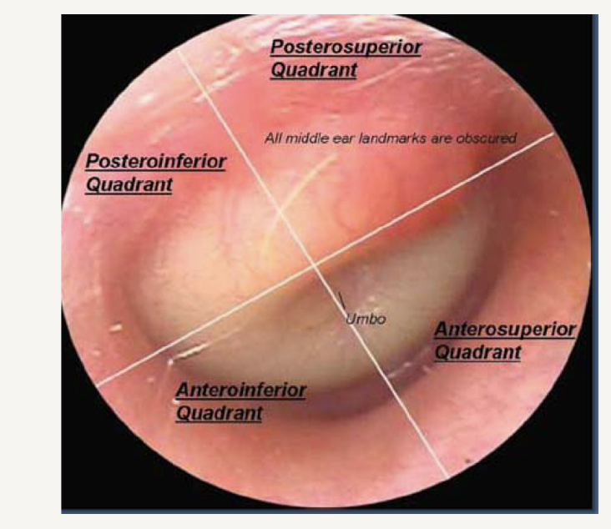
4 quadrants
- No malliolus seen, Purulent, buldging, no light reflex
Otitis Media with Effusion
Definition: blockage of middle ear, NON infected fluid behind the T.M
Risks: More common in children still, adults more common after URTI, may come after AOM*
Symptoms: NO PAIN, fullness of ear, pressure, hearing is different, crackling, bubbling, popping when crewing, Unilateral usually hearing loss
Signs: fluid line, bubbles, behind the tympanic membrane, redness, hearing loss(test), perforated discharge
Physical Examinations: otoscopy, same as AOM
Confirmatory Diagnostics: NONE
This is not an ACUTE Otitis Media.
Fluid accumulation is the result of poor Eustachian tube ventilation (blockage), not purulent middle ear infection fluid.
It may FOLLOW an acute otitis media due to residual inflammation in the Eustachian tube
- Counselling will go away after inflammation

Kids with repeat AOM may get tubes, they can still get infections but it will drain

Otitis Externa
Definition: infection of the external ear canal (anything before the TM), bacterial, yeast infection
Risks: adults > children; swimmers, diabetes, ear pickers (Q-tips),
Symptoms: bilateral pain, DISCHARGE** coming from infection process of external structures, stuffed ear, hearing loss (occasionally); may be associated with hx of swimming 1-2 days prior/ baths
- Ask what have you tried*
Signs:
Physical Examinations:
Visual Inspection (otoscope): inflamed, swollen external canal (canal may be swollen shut); discharge may be cheesy green-blue or grey; TM normal or not visible, may be red but no bulging, or fluid behind T.M, External structures are red/inflammed, cant put the otoscopy in so swollen**
Pinna manipulation often causes ++ pain big differential
Enlarged preauricular or postauricular nodes
Confirmatory Diagnostics: none

DONT MISS for Ears
MASTOIDITIS
Definition: infection of the soft tissue surrounding the air spaces in the mastoid bone
Risks: associated with bacterial otitis media
Symptoms: chronic otitis, pain behind the ear ** (ALSO PALPATE)
Signs:
Physical Examinations:
Visual inspection reveals erythema & swelling, boggy, soft instead of hard
Palpation of mastoid process reveals swelling & tenderness
Vitals: fever**, very ill
Confirmatory Diagnostics:
X-ray of the mastoid sinus
** If advanced, referral to ER for ? surgery
Can lead to meningitis, osteomyelitis, brain abscess, necrotizing fasciitis
Lymph nodes are not usually painful with inflammation/infection

Case Study #1
Terry (he/him), a 44-year-old construction worker, presents to your clinic reporting a red, itchy right eye for the past two days. He states that his right eyelid sticks together on waking and that he must wash the eye before he can open it. His left eye is bothering him as well now. He reports no change in vision, apart from increased sensitivity to bright light, and notes nasal congestion over the past five days.
Questions — Case #1
1. What additional key health history questions should the NP ask Terry?
2. What eye examination techniques will you include in your assessment?
3. Consider how your physical examination would differ if he had reported eye pain and a sensation of "something in my eye."
4. If the NP discovered a steel filing at the 3 o'clock position at the periphery of the iris, what would be the most appropriate next action?
Case Study #2
Beth (she/her), a 33-year-old early childhood educator, reports "excruciating pain in the left ear for the past 24 hours." She has no history of ear problems. The history reveals that she teaches swimming part-time for a competitive swim team at the local YMCA. She presents today because the pain is worsening, and she noticed white-to-yellowish drainage from her ear on her pillow this morning. She has no fever.
Questions — Case #2
1. At this stage, list the differential diagnoses the NP should consider based on Beth's presenting symptoms.
2. What physical findings would the NP expect to observe during the examination?
3. What is the most likely causative microorganism?
4. If the tympanic membrane could not be visualized, how should the NP rule out a middle ear infection?
Case Study #3
Eric (he/they), an 18-year-old college student, presents to the walk-in clinic with a fever, headache, and sore throat for the past three days. He informs the NP that he has difficulty swallowing, feels fatigued, and has developed a dry cough. He maintains his fluid intake but eats only soup due to difficulty swallowing. He denies any nausea, vomiting, or diarrhea. He presents today because he feels worse than he would with a simple cold.
Question 1: At this stage, list the differential diagnoses the NP should consider based on Eric's presenting symptoms. Provide your rationale.
The physical examination reveals:
• Temperature: 38.2 °C (tympanic).
• Lymphatic system: bilateral anterior cervical and submental lymphadenopathy, soft, mobile, and tender.
• HEENT:
• Nose: erythematous nasal turbinate, no discharge.
• Throat: inflamed pharynx.
• Tonsils: greyish-white exudate.
• The remainder of the examination is unremarkable.
Question 2: What is the total score using the Sore Throat Score?
Question 3: How predictive of a group A streptococcal (GAS) infection are this client's signs and symptoms?
Question 4: What complications are you concerned about, and what is the risk of these if treatment is delayed?
Question 5: Based on the clinical findings, what diagnostic investigations, if any, should the NP order? Provide your rationale.
Question 6: If the NP had noted splenomegaly during the physical examination, would this have changed the diagnostic reasoning?

- Pull up to examine ear under 3*
- Down for over 3
OSCE practice : AOM

OSCE Station: Acute Otitis Media (AOM)
You are seeing a pediatric patient in a primary care clinic, accompanied by a parent/caregiver. Take a focused history from the caregiver, review the simulated otoscopic examination findings, and communicate your working diagnosis and plan. You have 15 minutes before feedback.
Presenting complaint: “My child has been pulling at their ear and crying all night.”

Standardized Patient
Caregiver tells you: “She’s been tugging at her right ear since yesterday and had a fever last night. She barely slept.”

History: Reveal Only if Asked
- Age/sex: 2-year-old girl
- Onset: Ear tugging and fussiness started approximately 36 hours ago and worsened overnight
- Symptoms: Subjective fever/felt warm, irritability, decreased appetite, disrupted sleep, no ear discharge
- Preceding illness: Runny nose and mild cough beginning approximately 5 days ago. Upper respiratory infection preceding AOM is classic.
- Denies: Vomiting, rash, neck stiffness, lethargy, or tugging/pain in both ears. Symptoms are unilateral.
- Daycare: Attends daycare 3 days per week. A few other children have recently had colds.
- Past medical history: Born full term, no chronic conditions, no previous ear infections
- Medications: Caregiver gave weight-based acetaminophen last night with some relief
- Allergies: NKDA
- Immunizations: Up to date, including pneumococcal conjugate vaccine (PCV)
- Feeding: No bottle-propping or supine feeding reported
- Smoke exposure: None in the home

Red Flags: Answer “No” Unless Specifically Asked
- No stiff neck, bulging fontanelle if younger, persistent vomiting, lethargy/poor arousability, or facial droop
- No mastoid swelling, redness, or tenderness behind the ear
- No ear discharge, which would suggest tympanic membrane perforation

Vitals
- Temperature: 38.9°C, tympanic
- Heart rate: 118
- Respiratory rate: 26
- Weight: 13 kg
- General appearance: Fussy but consolable and interactive when distracted

Otoscopic Examination Findings
- Right tympanic membrane: Bulging, erythematous, and opaque, with loss of normal landmarks and reduced mobility on pneumatic otoscopy
- Left tympanic membrane: Normal, pearly grey, landmarks visible, and intact light reflex
- No perforation or discharge
- External canals normal bilaterally

Diagnostic Criteria Reference
Criterion | Finding in This Case
Acute onset of symptoms | Yes, approximately 36 hours
Middle-ear effusion | Yes, bulging and reduced tympanic membrane mobility
Signs/symptoms of middle-ear inflammation | Yes, erythema of tympanic membrane plus irritability/fever
Laterality | Unilateral, right
Severity | Moderate to severe. Marked bulging and fever ≥39°C would push to severe.
This presentation meets the diagnostic criteria for AOM. The candidate should discuss watchful waiting versus immediate antibiotics based on age, severity, and laterality. Exact prescribing decisions can be deferred if not yet covered in the curriculum. Focus on the reasoning framework.

Assessment Checklist

History
☐ Introduces self, confirms patient/caregiver identity, and explains purpose
☐ Elicits onset, duration, and laterality of ear symptoms
☐ Asks about associated symptoms: fever, irritability, sleep/appetite changes, and discharge
☐ Asks about preceding URI symptoms
☐ Screens for red flags: lethargy, stiff neck, mastoid swelling, and persistent vomiting
☐ Asks about risk factors: daycare, smoke exposure, feeding position, and previous ear infections
☐ Reviews immunization status, including PCV
☐ Uses caregiver-appropriate, empathetic communication because the patient is a child

Physical Examination
☐ States intent to check vital signs and weight
☐ Requests and interprets otoscopic findings for both ears
☐ Asks about or notes pneumatic otoscopy and tympanic membrane mobility
☐ Checks for mastoid tenderness or swelling
☐ Assesses general appearance and hydration status

Clinical Reasoning
☐ Applies diagnostic criteria correctly: acute onset, effusion, and inflammation
☐ Distinguishes AOM from otitis media with effusion and otitis externa
☐ Discusses watchful waiting versus antibiotic therapy with appropriate rationale based on age, severity, and laterality
☐ Identifies the need for follow-up and safety-netting

Communication
☐ Explains findings and the plan using caregiver-friendly language
☐ Addresses the caregiver’s concerns and answers questions
☐ Discusses pain management, such as weight-based analgesia
☐ Provides clear safety-netting regarding when to return: worsening fever, ear discharge, lethargy, or facial swelling
☐ Demonstrates empathy and professionalism throughout

Debrief Prompts
- What features distinguish AOM from otitis media with effusion?
- How would your management change if this were a 6-month-old instead of a 2-year-old?
Difference between ABX, also palpate skull in under 6 months
- What would make you consider watchful waiting rather than immediate antibiotics?
- What anatomical factors make young children more prone to AOM?

Facilitator Notes
- Swap roles and repeat with an otitis media with effusion variant: no fever, no acute pain, tympanic membrane retracted or neutral with effusion but no bulging or erythema, and the caregiver reports only mild hearing concerns. This is useful for teaching the distinction between AOM and OME.
- For a more advanced group, add a mastoiditis “spot the emergency” variant: post-auricular swelling, erythema, tenderness, and protruding auricle.

Week 3 Derm

- Remember what is normal ie thinning

History Taking
Onset/duration: When did the skin issue start? Did it start suddenly or gradually?

Provoking/Palliating: What makes it worse (ie. heat, sun, scratching, fabrics, soaps)? Any environmental, infectious exposures? What makes it better (ie. rest, cool compress, creams, antihistamines, topical steroids)?

Quality: How would you describe the lesion or sensation (ie. itchy, burning, painful, oozing, scaling)? Any discharge, pus or bleeding?

Region/Radiation/relationship : Where on your body did it start? Has it spread to other areas? Is it limited to certain regions, flexor/extensor surfaces or contact areas?
- Where did it start/spread?(infection), contact areas,

Severity: How bothersome is it on a scale of 0-10? Are there associated symptoms?

Timing/progression: Is it constant or intermittent? Does it flare at certain times (seasonal, after meals, during stress)? Any recent travel history? Is it getting worse?

U: How is this affecting you in your daily life? Do you have any thoughts about what it might be?

Things to Remember
- Acute vs. chronic rash
- Type of lesion(s)
- Changes in colour, shape, size
- Differentiation between presence of pruritus vs. burning vs. pain
- Location and progression of distribution (ie. Truncal to peripheral infectious disease; along specified unilateral dermatome in herpes zoster)
- Environmental exposure or contact with an infected person
- Fever may indicate an infectious process

Red flags
Fever angioedema, tender rash with mucus membrane involvement, edema, joint pain
Family Hx - autoimmune, CA, skin disorders
Systemic signs
Fever, night sweats, wt loss, fatigue, chills

Review of systems- MSK, CV, resp, GI, renal, neuro,
Scoriatic Arthritis* MSK pain
Allergies triad (IgE) mediated, family Hx
- allx , eczema, asthma

Morphological classifications
- Primary Lesions ***** ON EXAM, they will describe a lesion and what would the primary morphology it would be
  - Macules - flat, nonpalpable lesions usually < 10 mm in diameter. Ex: freckles, flat moles, tattoos
  - Papules - elevated lesions usually < 10 mm in diameter that can be felt or palpated. Ex: nevi, warts, insect bites, skin cancers
  - Plaques - lesions > 10 mm in diameter that are elevated or depressed / flat topped or rounded. Ex: Psoriasis
  - Nodules - firm papules or lesions that extend into the dermis or subcutaneous tissue. Ex: cyts, lipomas
  - Vesicles - small, clear, fluid-filled blisters < 10 mm in diameter. Ex: herpes, allergic contact dermatitis
  - Bullae - clear fluid-filled blisters > 10 mm in diameter. Ex: blistered burn
  - Pustules - vesicles that contain pus. Ex: folliculitis
  - Urticaria (wheals or hives) - elevated lesions caused by localized edema which are pruritic and red and common
  - manifestation of hypersensitivity to drugs, stings or bites, autoimmunity Typically lasts < 24 hours.
  - Scale - heaped-up accumulations of horny epithelium Ex: psoriasis, seborrheic dermatitis, fungal infections.
  - Crusts (scabs) - dried serum, blood, or pus. Can occur in inflammatory or infectious skin disease Ex: impetigo
  - Erosions - open areas of skin that result from loss of part or all of the epidermis. An excoriation is a linear erosion caused
  - by scratching, rubbing, or picking.
  - Ulcers -loss of the epidermis and at least part of the dermis. Ex: venous stasis dermatitis, decubitus ulcers, vasculitis
  - Petechiae - nonblanchable punctate foci of hemorrhage. Ex: platelet abnormalities – thrombocytopenia
  - Purpura -larger area of hemorrhage that may be palpable. Large areas of purpura = ecchymoses
  - Atrophy - thinning of the skin, (might be dry and wrinkled) resembling cigarette paper. Due to long term topical corticosteroids, aging, sun exposure, and some inflammatory or neoplastic skin diseases.
  - Scars - areas of fibrosis that replace normal skin after injury. Can become hypertrophic or thickened and raised.
  - Ex: Keloids - hypertrophic scars that extend beyond the original wound margin
  - Telangiectasis - foci of small, permanently dilated blood vessels Ex: occur in areas of sun damage, rosacea, systemic diseases, and long term topical corticosteroid use.

- Secondary Lesions- thickening of lesion
- Distribution of Lesions- symmet/asym/ , flexor(ezcema)/extensor(psoriasis) of joint, sun exposed areas, skin folds, hair line
- Shape and Arrangement - anular(ring shaped), linear, clustered, dermatomal
- Border or Margin- well defined (sharply demarcated) or ill-defined, is it advancing, growing, flat or raised boarder
- Associated Changes within Lesion- surface colour, vascular, spidery blood vessels
- Pigmentation- hypo/hyper, hemosiderin staining (dark sock area, like a bruise)

Driven by the History :
- Assess the skin and mucous membranes
- Inspect the distribution/pattern of the rash/lesions
- Inspect the mouth
- Don’t forget the scalp, hair and nails!!
- Touch the skin/area of concern
- Palpate regional lymph nodes
- Perform ENT, cardiovascular, respiratory, abdominal exams as appropriate
- Perform joint assessment as appropriate
- MEASURE THE LESION

Margination – Well-defined (traced with the tip of a pencil) or ill-defined
Shape – Round, oval, polygonal, polycyclic, annular (ring-shaped), iris, serpiginous(squiggle, snake like) umbilicated
Palpation
- Consistency (soft, firm, hard, fluctuant, board-like("board-like" or heavily indurated skin lesion feels unusually firm, rigid, or woody to the touch, indicating deep thickening, scarring, or infiltration beneath the surface of the skin)
- Deviation in temperature (hot, cold)
- Mobility (moveable or not)
- Presence of tenderness and estimate depth of the lesion (dermal or subcutaneous, epidermis), also note how TALL it is

Evaluation of Arrangement, Patterns and Distribution

Number – single or multiple
Arrangement – Multiple lesions may be
Grouped: herpetiform, arciform, annular, reticulated, linear, serpinginous disseminated OR scattered, discrete lesions
Confluence – merging together to form a mass

Distribution
- Extent (isolated/single lesion, localized, regional, generalized, universal)
- Pattern (symmetric, exposed areas, sites of pressure, intertrigous area (skin folds, pannus area gets candida) , follicular(hair) localization, random, following dermatomes)
- Mobility (moveable or not), for lumps is important
- Presence of tenderness and estimate depth of the lesion (dermal or subcutaneous)

Lab/Diagnostic Investigations
- Diascopy- glass test, press glass to lesion blanching
  - Many harmless rashes blanch with pressure
  - Meningococcal rash will remain red or purple** CLUE

- Dermascopy
- Wood’s Lamp-- UV light vitiligo, fungal vs bacterial
- Skin Scraping for KOH- take BIOPSy tests for yeast and dermatophytes
- Bacterial/Viral Culture (swab)
- VDRL - BLOODWORK, for syphilis, venereal disease research lab
- Punch Biopsy Punch Biopsy (next week)
- Excisional Biopsy Excisional Biopsy (next week)

- Tertiary syphilis brain deterioration

RED FLAGS
- Angioedema, airway compromise**- mouth swelling lips, tongue, allergic reaction

- Very rapid progression (necrotizing fasciitis) **
- Widespread rash, blistering or skin detachment (Stevens-Johnson Syndrome TOXIC epidermal necrolysis)
  - Usually medication or immunization allx
  - Joint pain, fever, bulla
  - *mucus membrane check
  - 1-3 days before eruption before skin
  - Diffuse rash, detachment of skin
  - Can be idiopathic
  - Microplastic pneumonia or viral
- Necrosis
- Associated fever, chills, night sweats, weight loss, malaise
- Hemodynamic instability (hypotension, tachycardia, confused = sepsis)
- Spreading erythema, warmth, swelling, pain (cellulitis, erysipelas)
- Lymphangitic streaking (lymphangitis, risk of sepsis)- Infected lesion, red streaks up to the heart**

- Scalp tenderness (with other features of temporal arteritis-- swelling/redness over temporals +tenderness
- Mingocococcemia- use blanch testing, early presentation erythemia, maculas and papula viral exantham, followed by papitica mucosa conjunctiva
  - After BP petechieal( small bruising after BP)
  - Test for more signs of severe infection confusion, fever, chills
  - Other symptoms
  - DIC(disseminated intravascular coagulation) shock and death
  - Appearance: Looks like tiny red/purple dots that do not fade or lose color when you press on them (non-blanching).Progression: Can quickly evolve from a few scattered spots into widespread bleeding under the skin or large blood blisters in severe cases.Location: Often appears first on the trunk and legs, but can also show up on mucous membranes, the conjunctiva of the eyes, palms, and soles.Skin Tone Variations: On darker skin tones, the spots may appear dark blue, dark purple, or black rather than bright red or pink.The Glass Test: Pressing the side of a clear glass tumbler against the skin; if the spots remain visible through the glass without fading, it is an emergency.Accompanying SymptomsSudden high feverSevere headache and stiff neck (if meningitis is present)Extreme lethargy, confusion, or irritabilityCold hands and feet, muscle pain, or rapid breathing

- Inclusive anatomy website for anatomy

Case Study:

Martha (she/her), 59-year-old, presents to the clinic, reporting an itchy rash on her hands and arms that developed two days ago. She reports that the rash is also on the front of her legs and that there are little blisters on her legs and hands. She has no allergies, has no chronic conditions and takes no medication.

The health history reveals:
- She states she has spent the past week clearing brush at her friend’s summer cottage. She washed herself and her clothes with soap and water after noticing the rash. She admits that the rash only appears in exposed areas.

Question #1: What other key health history questions should the NP ask Martha during the health history?
- Changes to laundry, hiking, exposures, gardening, makeup, new medication?
- Any recent fever, any other symptoms
- Has it gotten worse? Did it start with other symptoms, tingling numbness
- characteristic - itchy, painful
- Tried anything to make it better or worse?
- Anyone at home with a similar rash?
- Travel?
- Have you had anything like this before?

Question #2: What part of the history is most likely to guide you to the diagnosis?
- Clearing brush*
- Rash only to exposed areas*
- Washed with soap after
Question #3: What is the most likely diagnosis? Identify the key features that guided your decision and compare the findings you could have found for other potential differential diagnoses.
- allergic contact dermatitis - cause unknown (could be from poison ivy) but not 100%
- exposed skin
- Itchy***, poison ivy or soap
- Ill defined boarders, vesicles multiple in one area, ill-defined boarders, raised, erythematous

Differentials
Atopic dermatitis
Herpes zoster(shingles) -- usually in 1 dermatome*, PAINFUL, (tingling/pain before hand),
Herpes simplex - PAINFUL, prodromal(tingling/pain before hand), usually lips, nose, genitals

Case study 2:
**** MULTIPLE CHOICE SELECT ALL THAT APPLY ****
Alexa is a 35-year-old female (she/her) who comes to clinic for routine screening. Upon observing the skin of Alexa’s face, the NP notes that there is redness in the scalp margins, eyebrows, paranasal and nasolabial folds. The skin appears inflamed at the margins and there is a white flaky scale over this reddened base. Alexa claims that she has had this for a few years. It is not itchy. It has not spread. There is no discharge.
There is no discomfort associated with it.
#1: List THREE (3) differential diagnoses the NP should consider, given this clinical skin presentation.
- Psoriasis (usually patches,plaques, can be itchy, can be sore, if they have it on more parts of the body it would be indicative of psoriasis)
  - Auspitz sign- scratch test, looking for pin point bleeding at scratch site
- Seborrheic dermatitis (less discrete can cover a large area)
- Fungal infection (itchy)
- Dry skin

#2: Identify the ONE (1) most likely diagnosis for this skin condition?
- Seborrheic dermatitis - no pain, no discharge, no itchiness
- Nasal folds, hair, ears, eyebrows**
- Waxy build up that you can comb off vs psoriasis its a hard plaque
- fungal - flatter, itchy, scaly

#3: Identify the ONE (1) organism is believed to play a role in the etiology of this condition?
- Malassezia furfur (fungal)- NOT ALWAYS the cause
- Treat as primary diagnosis first, if does not improve switch it

#4: Identify one diagnostic test, which would confirm this condition? If there is no diagnostic test, state none required.
- Scratch test rule out psoriasis
- Histopathology sample of it, same for yeast

Think of VINDICATE for differential*
Think of 5 of similar
Choose test to rule in and out

Midterm multiple choice***

Dermatitis** BIG ONE
Atopic (Eczema) - asthma, allergies
- Can present different skin tone, can be darker or purple colour
- litchinification *
Contact (Allergic)
Seborrheic

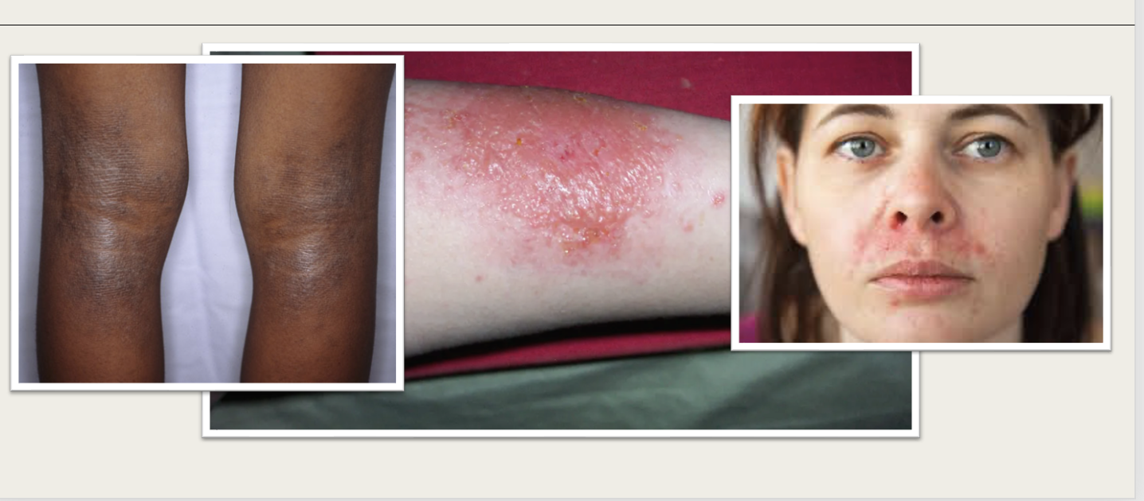

1.Atopic derm with lichinfication *** FAMILY history is a huge clue
2.Contact derm
3.Seborrheic dermatitis chronic relapsing, with dandraf(severe) (but does look like perioral dermatitis 90%women, use of corticosterioid before that, floride toothpaste, hormonal, doxycycline for 6weeks)
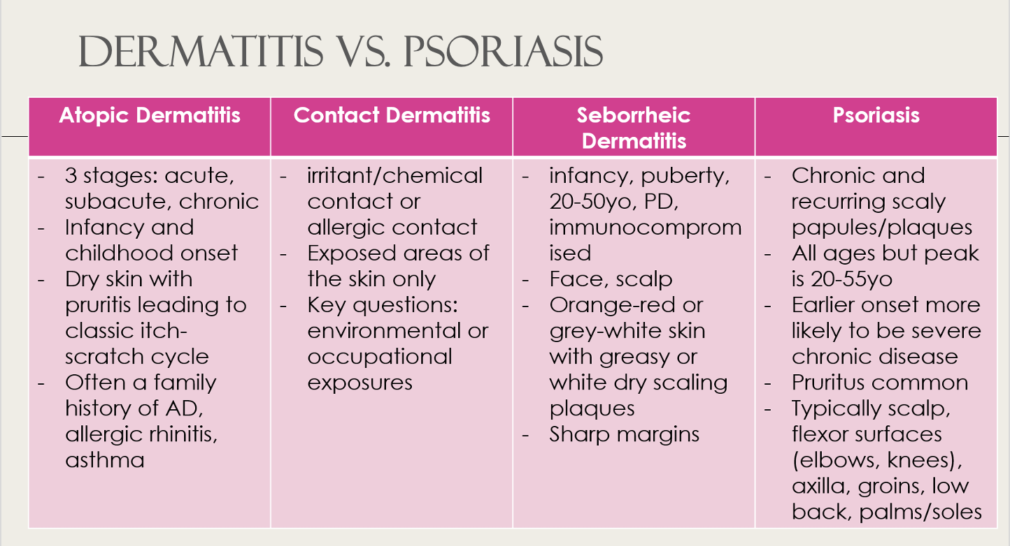

Impetigo
- honey coloured crust, children
- S. aureus (BULLOUS)*, Group A strep(NON-bullour

Hand foot and mouth
- Viral ** coxsackievirus
- Mouth sores
- Can get fever

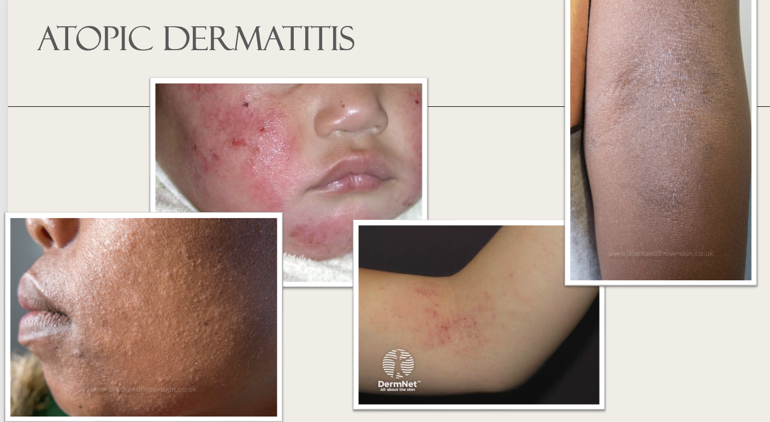

Babies cheek Primary*
Excoriation (skin break)--- also a clue for impetigo differential

Acne Vulgaris

Definition: An inflammatory disease of the pilosebaceous unit, which consists of a hair follicle and its accompanying oil (sebaceous) gland.

Excess Oil: The skin produces too much sebum (oil).
Clogged Pores: Dead skin cells and oil plug up the hair follicles.
Bacteria: A bacterium called Cutibacterium acnes multiplies inside the clogged pores.
Inflammation: The trapped oil and bacteria cause swelling, redness, and pus.

Open Comedone: Blackhead
Closed Comedone: Whitehead
Inflammatory: erythematous, cystic/nodular, pustules

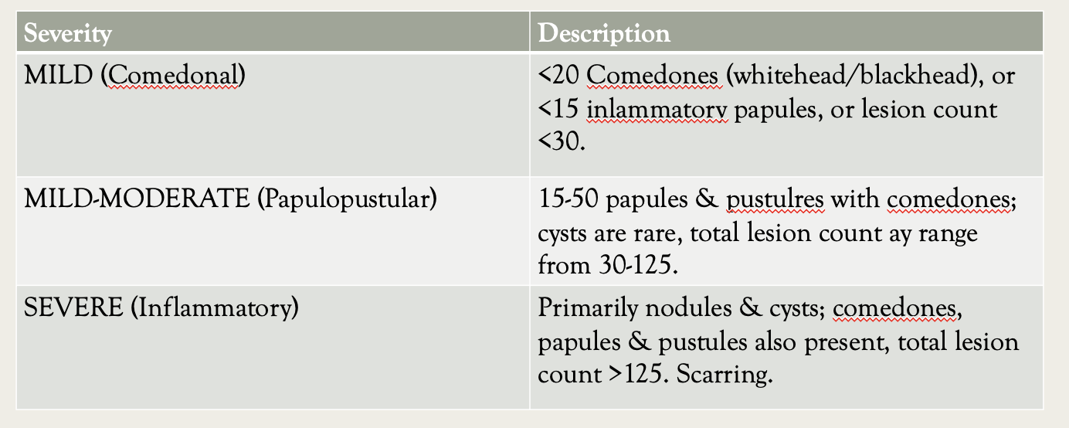

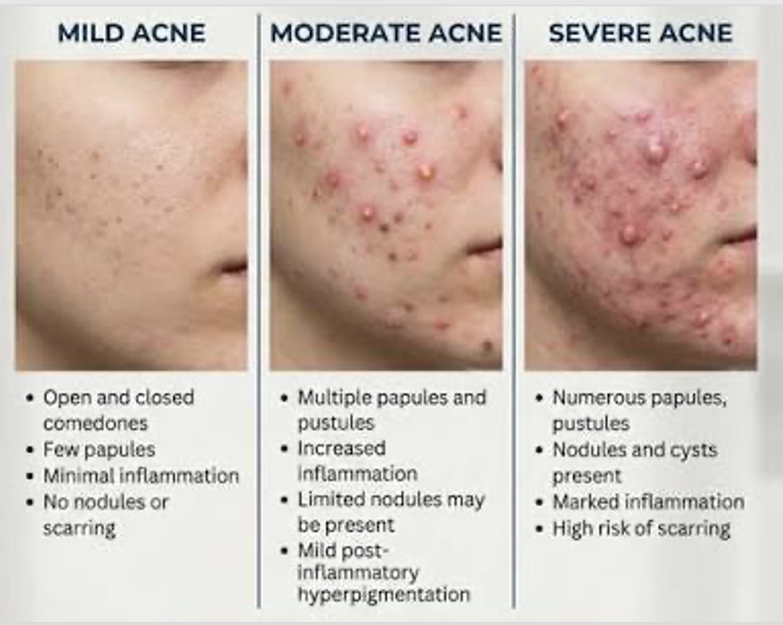
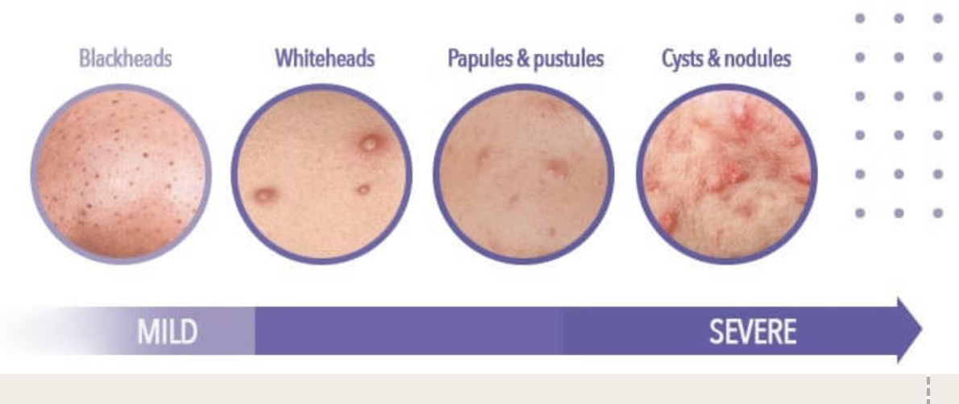

Differentials
1. Peroral dermatitis- pustules around mouth * nose, rarely around eyes, tiny dark clusters of bumps
2. folliculitis - uniformed, whiteheads, clusters, itchy**, tender, hair follicles, tight, groin, back
3. Acne rosacea- sudden flushing stays central, starts after age 30,erythema

Periorbital - around eyes*

Acne- face chest back, young adult, hormonal

Scabies

The hallmark is intense pruritus, characteristically worse at night, driven by a delayed hypersensitivity reaction that typically appears 4–6 weeks after initial infestation (sooner with reinfestation).
Classic scabies: excoriated pruritic papules, plaques, and pathognomonic burrows in the finger/toe web spaces, volar wrists, ankles, axillae, buttocks, periumbilical skin, male genitalia, and areolae.
Infants/young children: atypical distribution including palms, soles, neck, and face; vesicles, pustules, and nodules; fussiness and poor sleep may predominate over visible scratching.

Diagnosis is usually clinical, based on the characteristic rash distribution plus nocturnal pruritus, ideally with affected close contacts. Confirmation is by skin scraping of a burrow with mineral oil or KOH prep showing mites, eggs, or feces (sensitivity is examiner-dependent), or by dermoscopy (delta-wing sign for the mite, double-edged sign for the burrow).
Crusted (Norwegian) scabies: hyperkeratotic, "sand on skin" plaques (often hands/feet), a severe high-burden form seen in immunosuppressed (advanced HIV), elderly, or debilitated patients; highly contagious.

*** LINEAR PATTERN defining feature

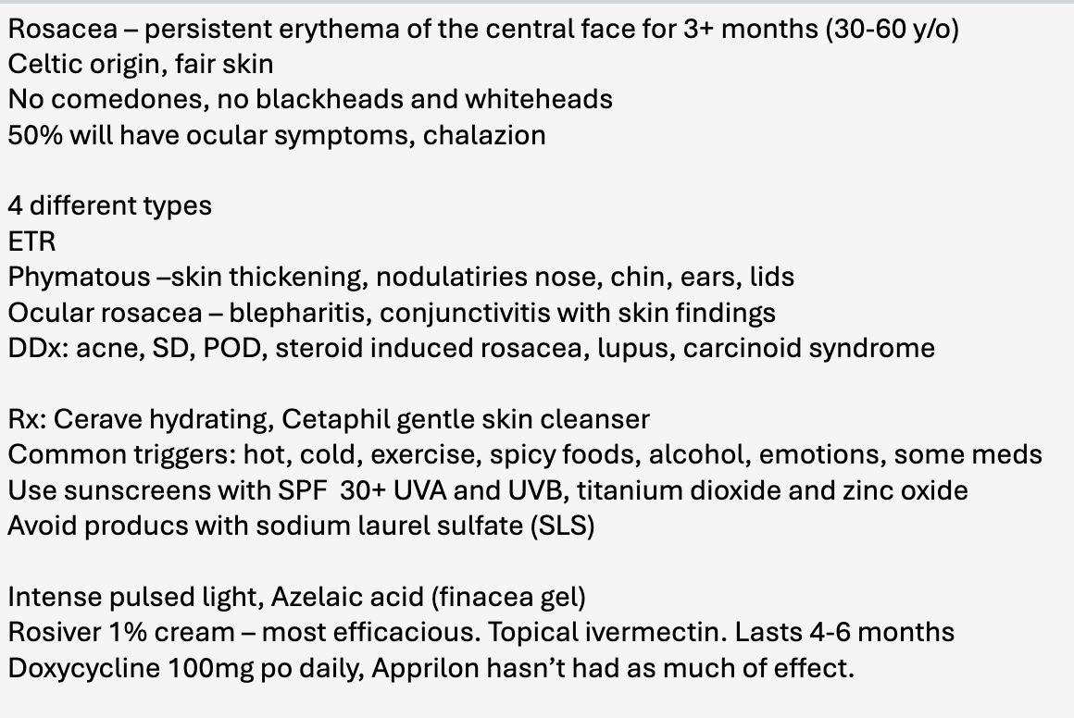

- Candida- usually satellite spots
Derm Week 4

images
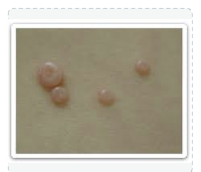
- Pearly, umbilicated, pink, papular, multiple lesions, dome shaped
- Mulluscum contagiousum( would know with the umbilicated/ dimple, AGE(common in children)
- Diff warts or skin tags, BCC(usually just one lesion, ulcerated/scabbed, telangicatan)
- 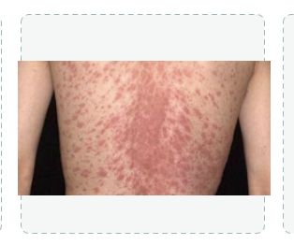

- diffused , erythematous, trunkal, patches- CHRISTMAS TREE*** follows skin crease lines, scaly topped, can be itchy**
- Pityriasis rosea -is a harmless, non-contagious skin rash that starts with a single large "herald patch" and clears up on its own within 6 to 8 weeks
- Differential- contact dermatitis, acne (open/closed comadomes, papules), tinea, SYPHILIS LOOKS LIKE THIS**
- Ask how it started** pityriasis starts as heralds patch
- syphilis -risky behaviours but STARTS with ulcer in genitals, ORAL mucosa**
  - Test to rule out VDRL blood test-- VERBALIZE THE THINKING**

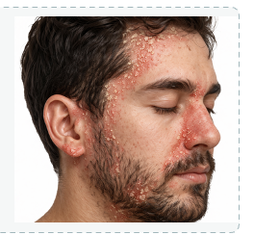
- Erythematous base, yellow scales, facial, hairline, nasal labial and beard
- Seborrheic dermatitis- waxy** yellow, on face/folds
- Diff- psoriasis, eczema

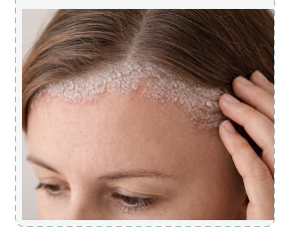
- grey /white/ silvery, scaly plaques, lace like, hair line/scalp, erythematous base
- Psoriasis - location, extensor, usually not on face, white/grey
- Diff- seborrheic dermatitis, eczema
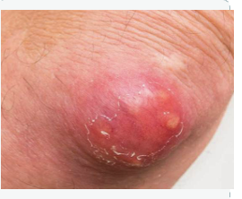
- raised , erythematous, pustule, annular, yellow filled, firm
- Carbuncle (multiple pustules underneath) or abscess, can be tender/painful
- Furuncle (1 pustule/hair follicle)
- When it combines into 1 large pustule

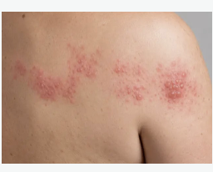
- Vesicular rash on erythematous base, painful, on 1 dermatome
- Herpes Zolster - dermatome, PAINFUL not itchy,
- differential : herpes simplex** -explain thoughts ie if it reoccurs like coldsores*

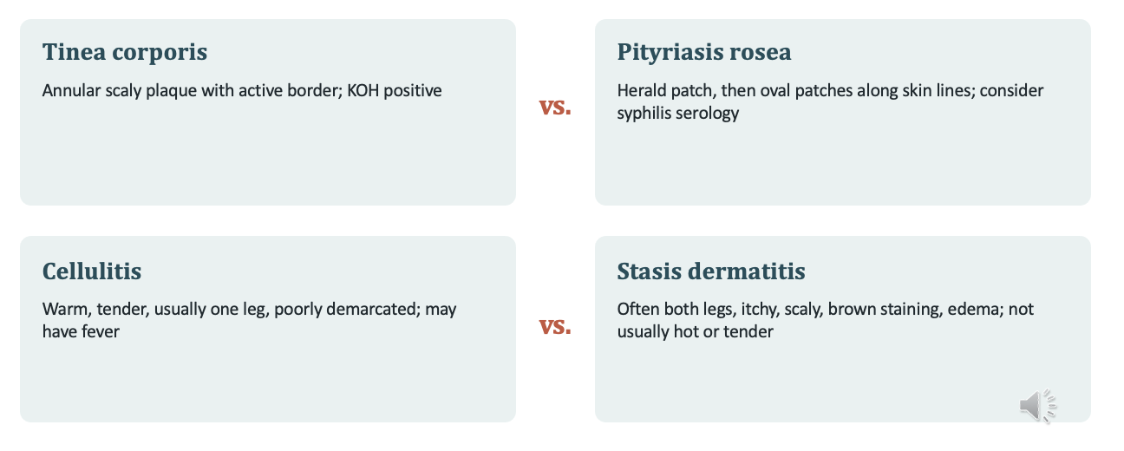
- syphilis - lesions on palms and soles, lymphadenopathy, fever, lesions/ULCERS,
  - Genital, oral, anal Ulcer, sexual risk factor, rash lasts longer/ atypical
  - Hair loss?

Cellulitis
- Painful, fever
Stasis dermatitis
- Both legs, ITCHY** brown staining, not hot or tender like cellulitis

Laceration
- WHO- Healing risks: diabetes, PVD, steroids, anticoagulants, immune status; allergies
- WHAT-Mechanism and force; contamination (soil, saliva, feces); foreign body
- TETANUS- Ask when and why the last dose was given
- WHEN-- Time since injury shapes the closure decision
- WHERE- Neurovascular status, tendon function through full range, joints, face( refer out)
- EXPLORE- after FREEZING** Irrigate and examine to the base: debris, tendon, joint capsule

Physical Exam
- Ensure appropriate lighting, gauze, and rinse materials are easily accessible before beginning the exam.
- Establish hemostasis: Hemostasis should be established to allow for visualization of underlying structures and foreign objects, utilizing direct pressure.
  - Blood pressure cuff above the wound, or tourniquet
- Detailed neurologic exam: The clinician should perform a complete sensation exam at and below the level of injury before using any anesthesia to assess for any nerve injury. A quick method to evaluate for nerve injury is 2-point discrimination using a standard paper clip, always comparing to the patient's noninjured side.
  - ABOVE AND BELOW and also BEFORE FREEZING, compare to NON injured side
- Detailed musculoskeletal exam: Examine any joints involved in the laceration for injury, along with an active and passive range of motion exam above and below the joint to assess for tendon injury.
- Detailed Vascular exam: If the wound is on the extremities, assess the capillary refill distal to the wound and always compare it to the noninjured side. If accessible, Doppler ultrasound can assess underlying vascular integrity from above the laceration to below.
  - If decreased pulses- refer to vascular or plastics
- If observed, foreign bodies should be removed, as they can increase the patient's risk of infection or poor wound healing. Imaging should be obtained if there is any concern about retained foreign bodies.
- Lip or EYE lid margin cosmetic- refer to plastics if uncomfortable

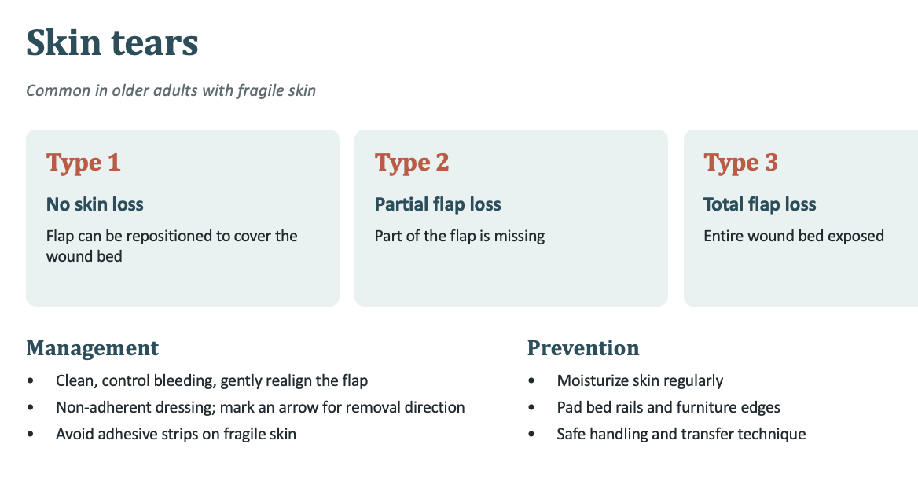

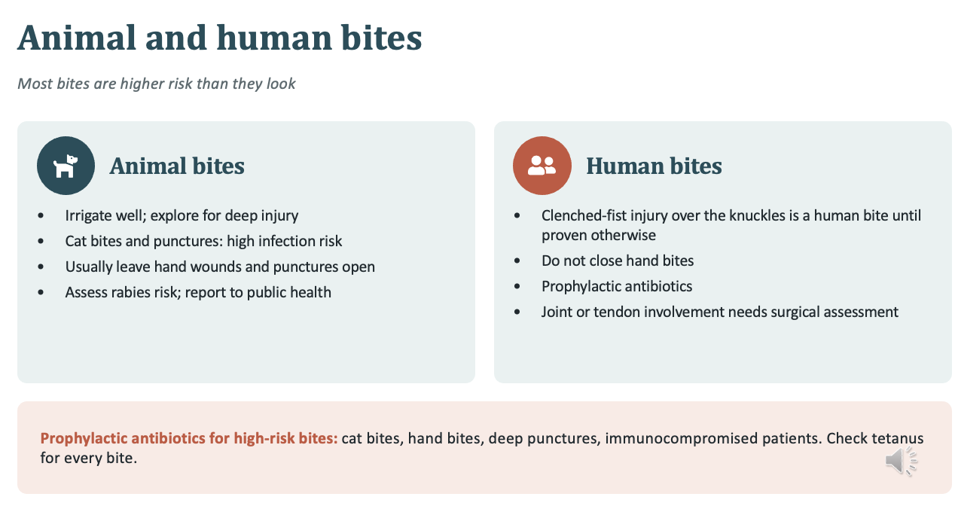
- Bacteria **
- Deep puncture, cats, dogs
- Rabies and tetanus
- Usually leave open to drain

- Cat scratched cellulitis

 | Venous | Arterial | Diabetic (neuropathic) | Pressure injury
Location | Gaiter area, medial malleolus | Toe, lateral malleolusm pressure points | Planter pressure points, under callus | Over body prominences
Appearance | Shallowm irregular, moist | Punched out, pale, necrotic , dry | Callus rim often painless | Staged by depth
Surrounding skin | Edema brown staining, stasis dermatisis | Shiny hairless, cool, uber | Reduced sensation dry skin | Non blanchable erythema, may look purple or darker on dark skin
Pain | Aching better with elevation | Severe worse with elevation | Often absent | variable
Key test | ABI | ABI or toe pressure | Monofilaent, probe to bone | Braden scale
Core care | Compression once aterial supply confirmed | Vasc referral no compression | Offloading, and glucose control | Repositioning, pressure redistribution

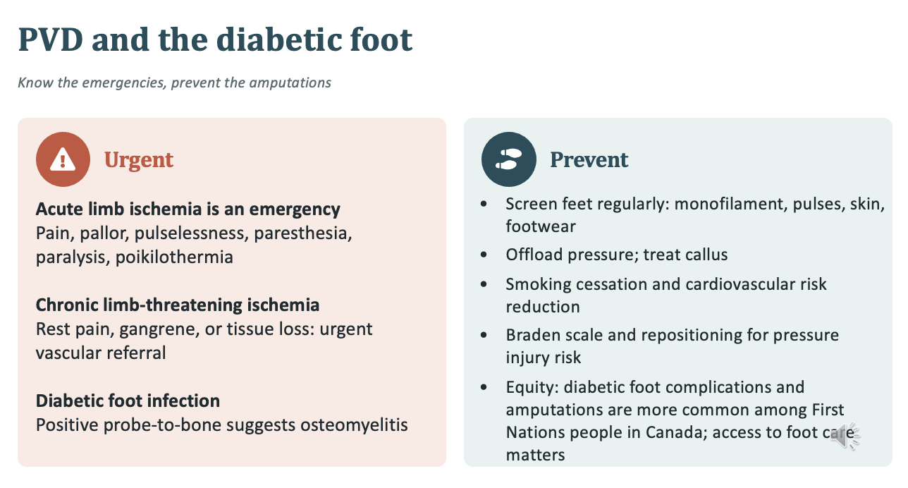

- poikilothermia - unable to regulate temp
- Frame the equity point structurally: access to foot care, specialist services, and follow-up, not individual blame.
- Callus- can cover pressure wounds
- smoking - vasoconstriction- no smoking before ABI

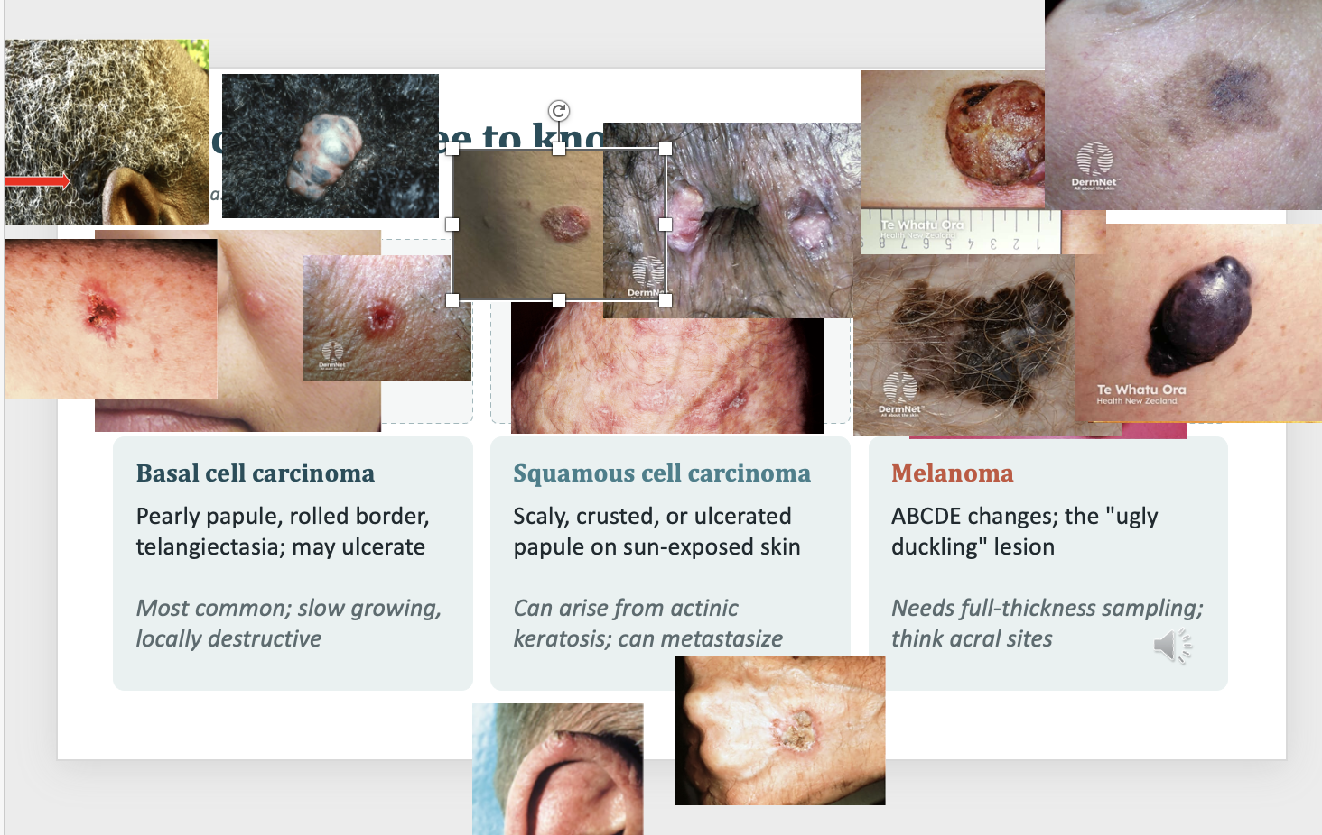
- BCC- raised, can be tumor like
- SCC- scaly crusted, slightly raised, AK, crusts, occasionally bleed, can pick at it, ears cauliflower looking, persistent scaly patch irregular borders crusts and bleeds
  - Diff- tinea or psoriasis
  - Chronic non healing ulcer- can be genital areas for dark skinned people
- Melanoma- darker multicoloured, ABCDE**
  - Finger nail- melanonychia - Which is a normal finding for dark skinned people but will be on MULTIPLE nails, not changing, usually thinner strip
  - Melanoma of the nail is usually wider/thicker, 1 nail and changing**
  - Classically spreading- 80% mole like but flatter-- ABCDE
  - nodular melanoma, raised - 10-15%
  - Light coloured melanoma- Amelanotic Melanoma,- often at first resemble a freckle, but changes over time
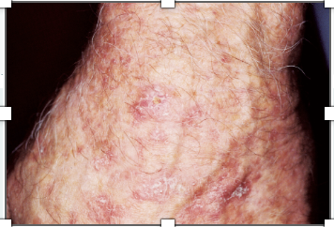 Actinic Keratosis - precursor to SCC
- If quickly recurring after removal - could be bad sign
- White scaling, rough

Cryotherapy
- Can be NOT covered for patients
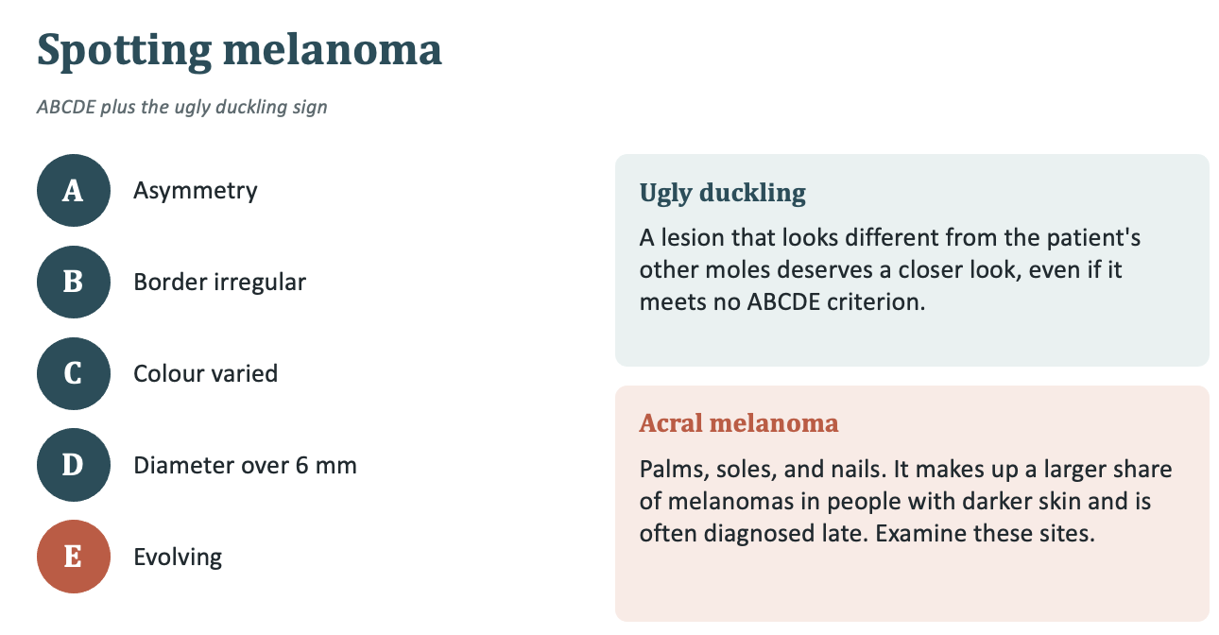

E. Elevated
F- firm to touch
G growing
ABCDEEFG

Nodular melanoma- Firm** elevated
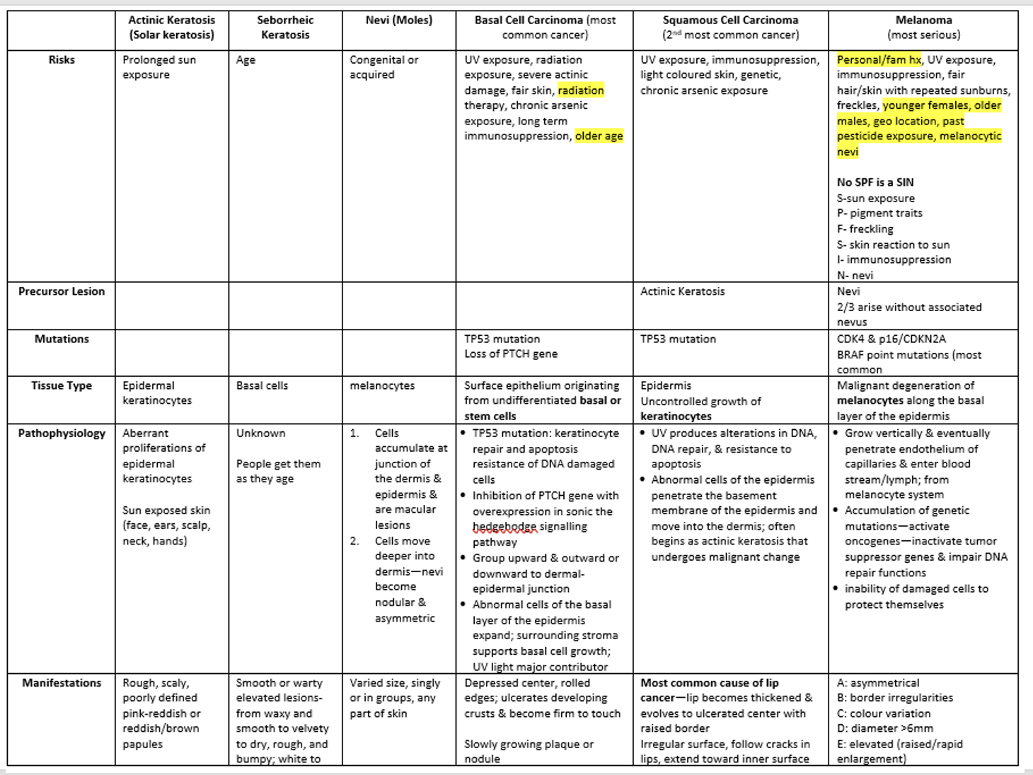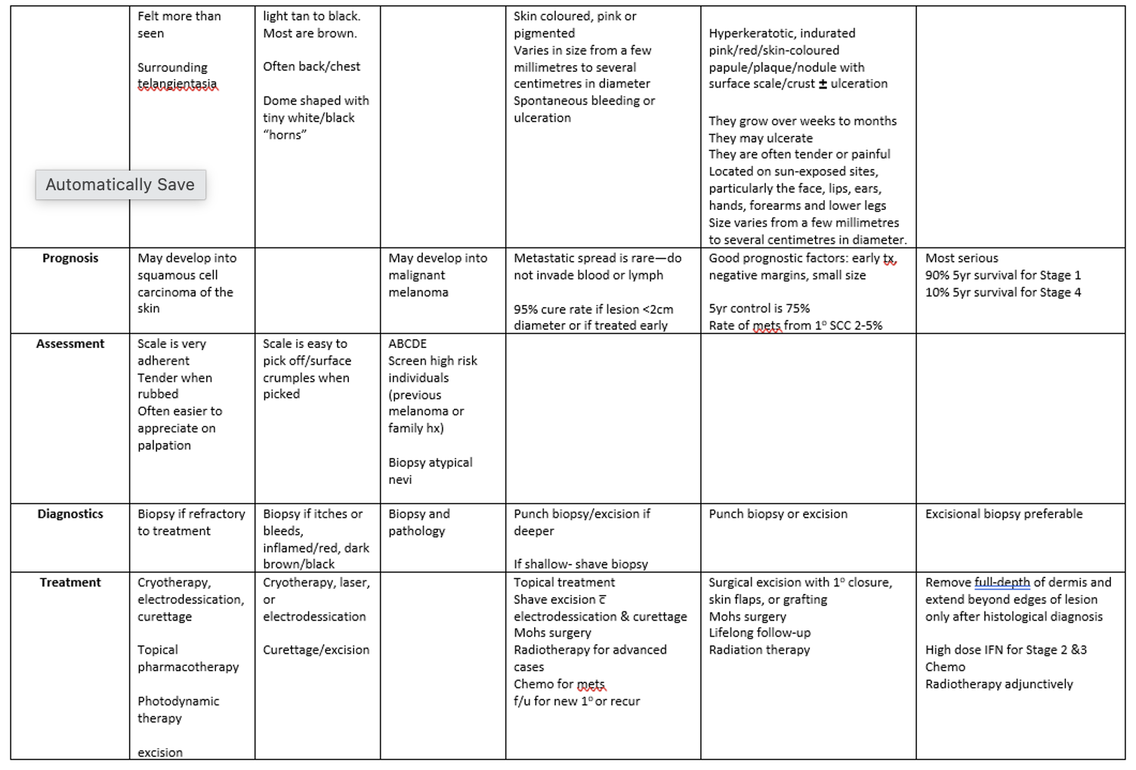

Sunprotection ***
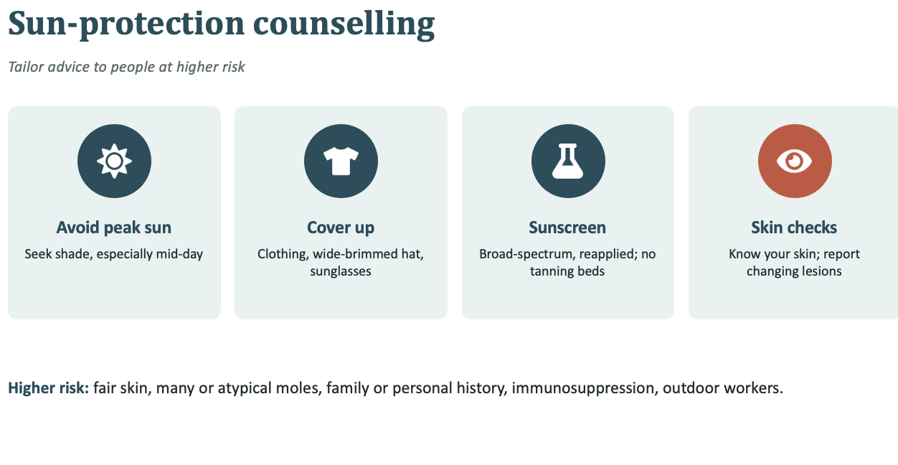
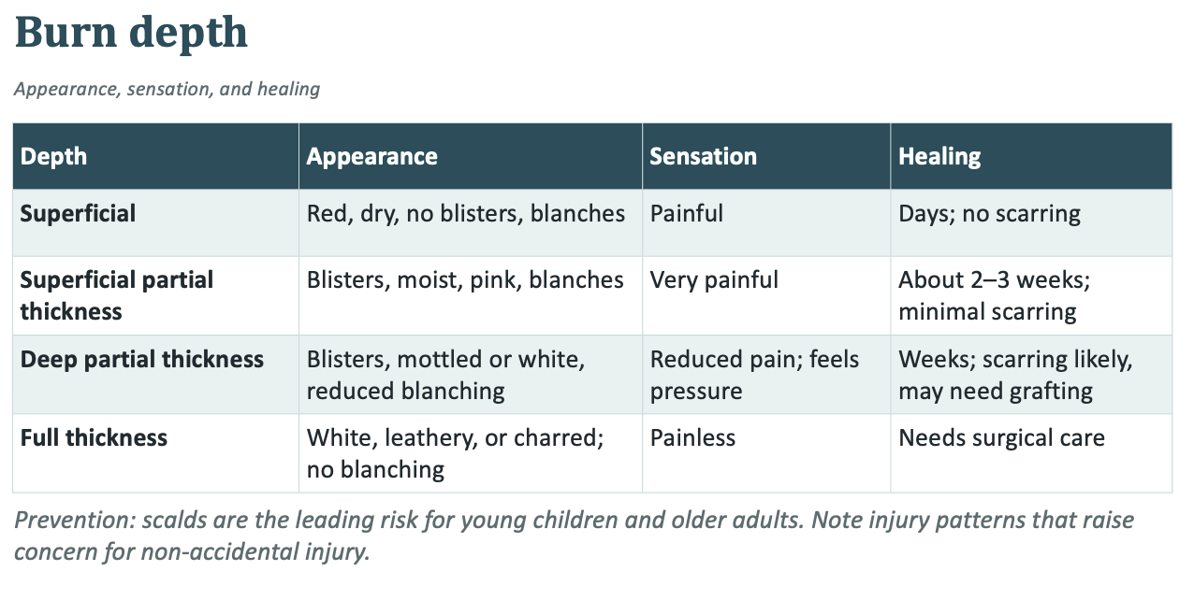
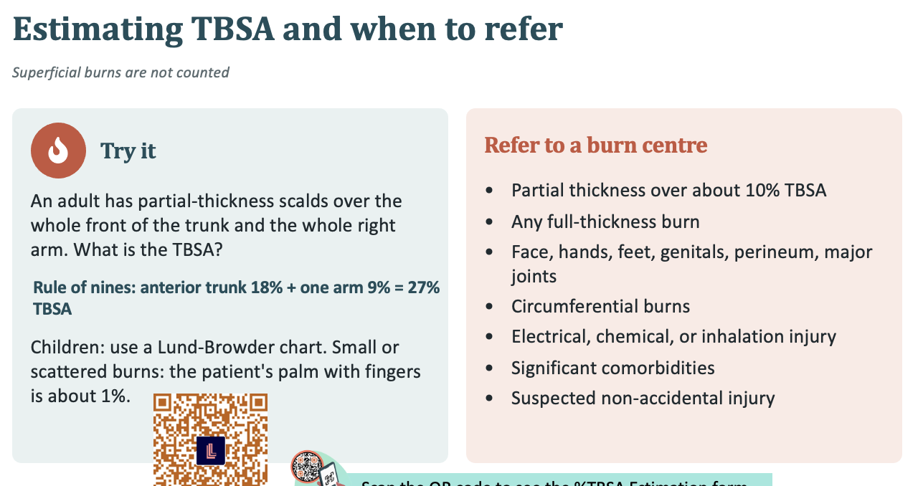

Know rough estimation
TRUNK IS 13**

Laceration
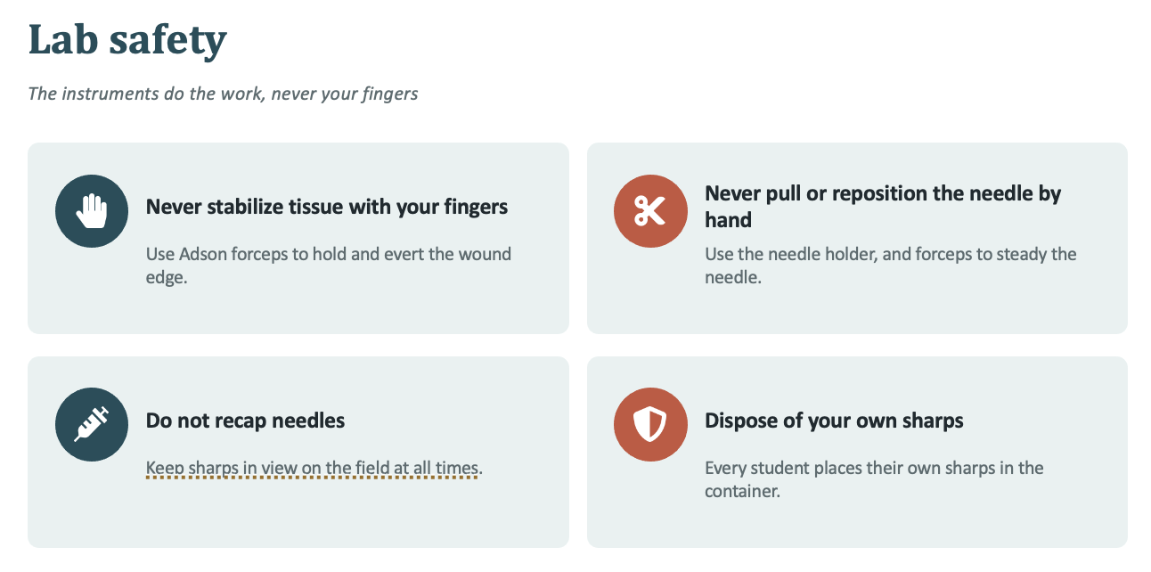
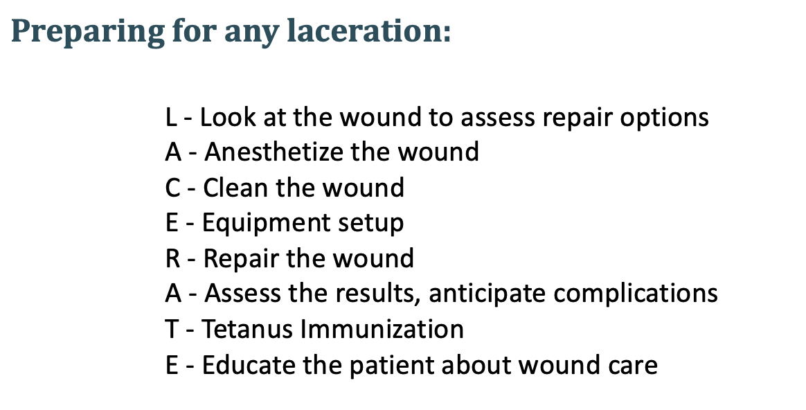
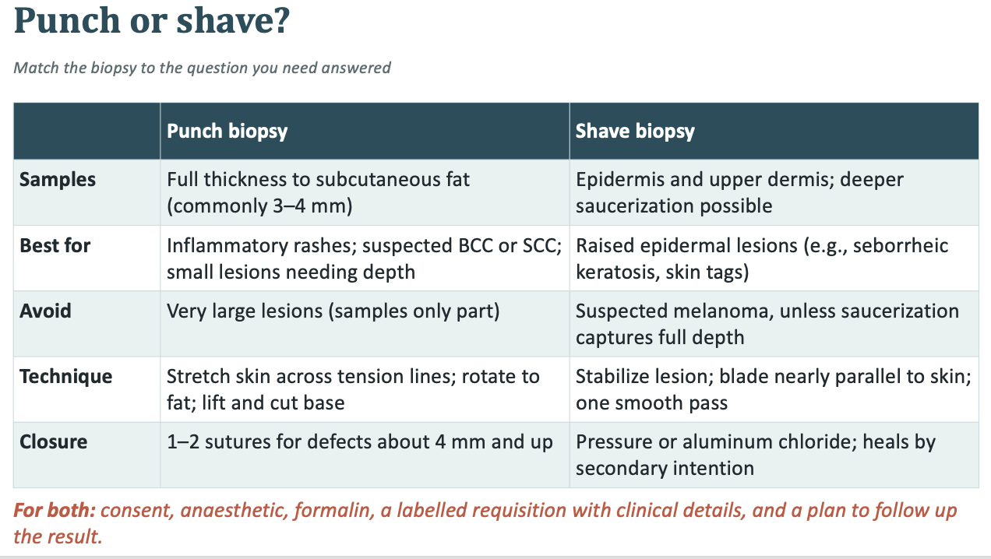
-Demonstrate a punch and a shave biopsy on a practice pad. Link back to Part 2C: a changing pigmented lesion needs full-thickness sampling.
-

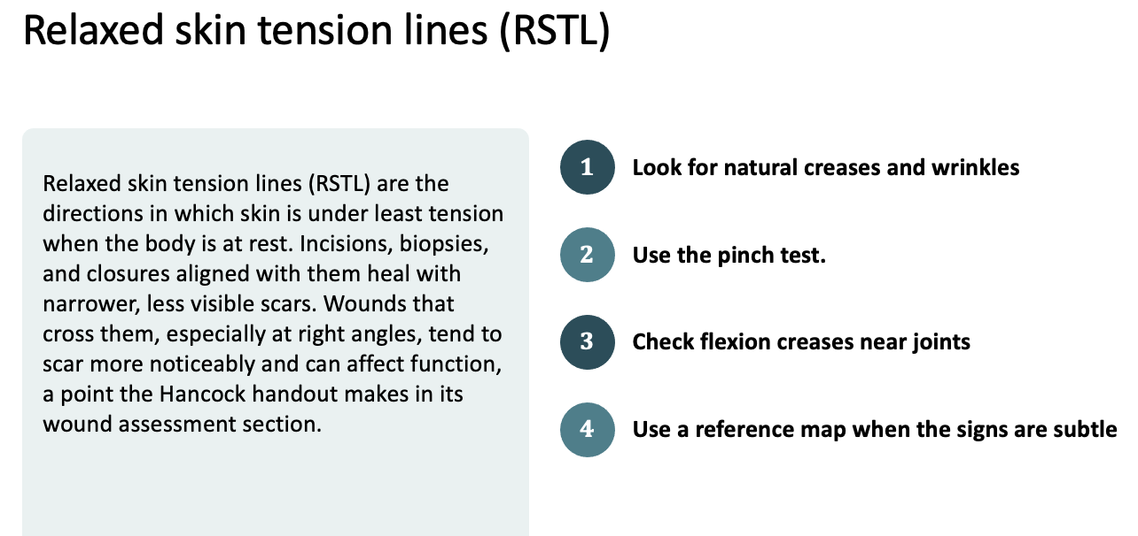
Look for natural creases and wrinkles. RSTL usually run with existing wrinkles, especially in older adults. On the face, ask the patient to raise their eyebrows, frown, smile, squint, and purse their lips. The lines that appear run roughly perpendicular to the underlying muscles of facial expression, such as horizontal forehead lines, crow's feet, and nasolabial folds.
Use the pinch test. Gently pinch the skin between your thumb and index finger, then repeat in a few directions around the site. When you pinch perpendicular to the RSTL, the skin forms several fine, straight, parallel furrows. When you pinch along the RSTL, you get fewer, irregular, S-shaped folds. The direction with the neat parallel furrows shows the line's orientation.
Check flexion creases near joints. Over joints, the lines follow the skin creases, which run perpendicular to the direction of movement. Flex and extend the joint to see them.
Use a reference map when the signs are subtle. Children and people with smooth or taut skin may show few wrinkles, so rely more on the pinch test and on typical patterns. In general, facial lines follow expression lines, trunk lines run roughly horizontally or obliquely, and limb lines run largely transverse, especially near joints.

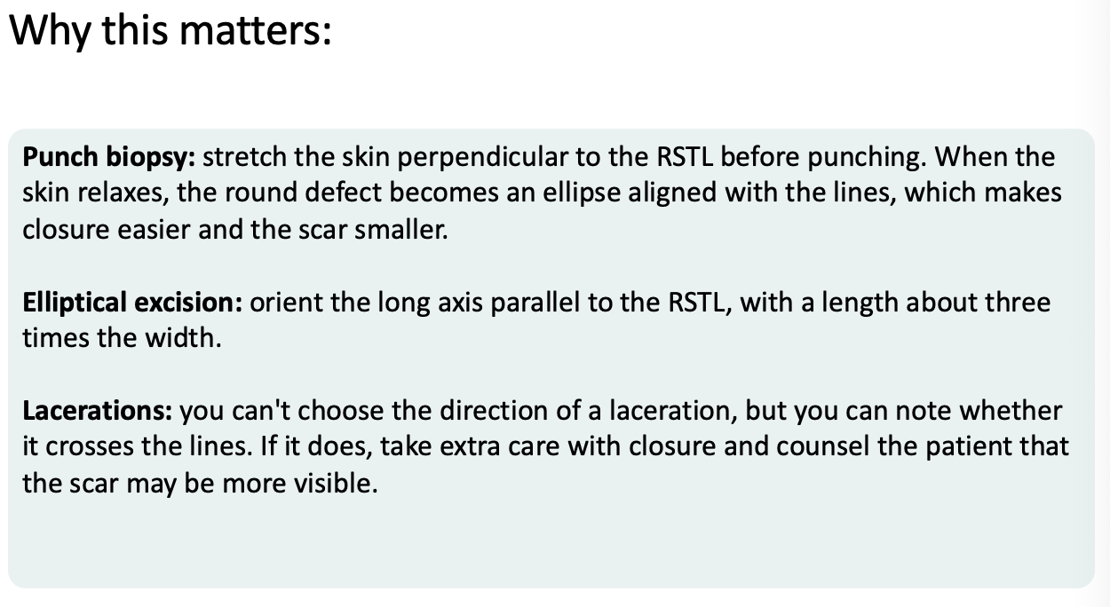
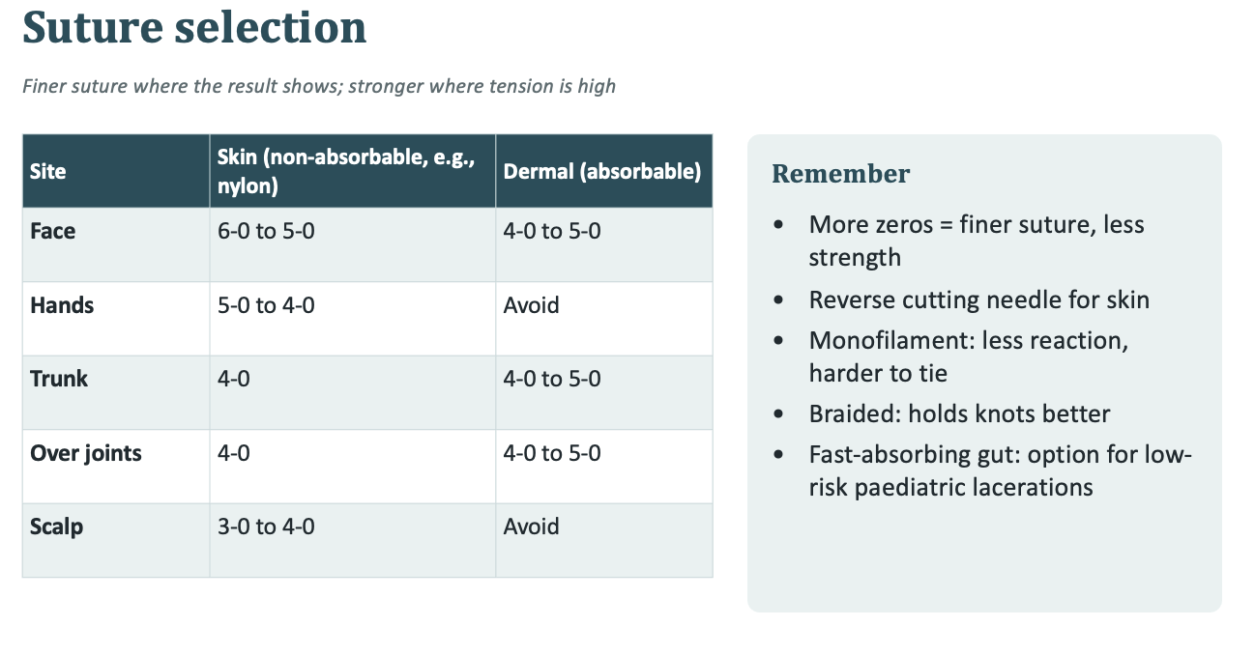

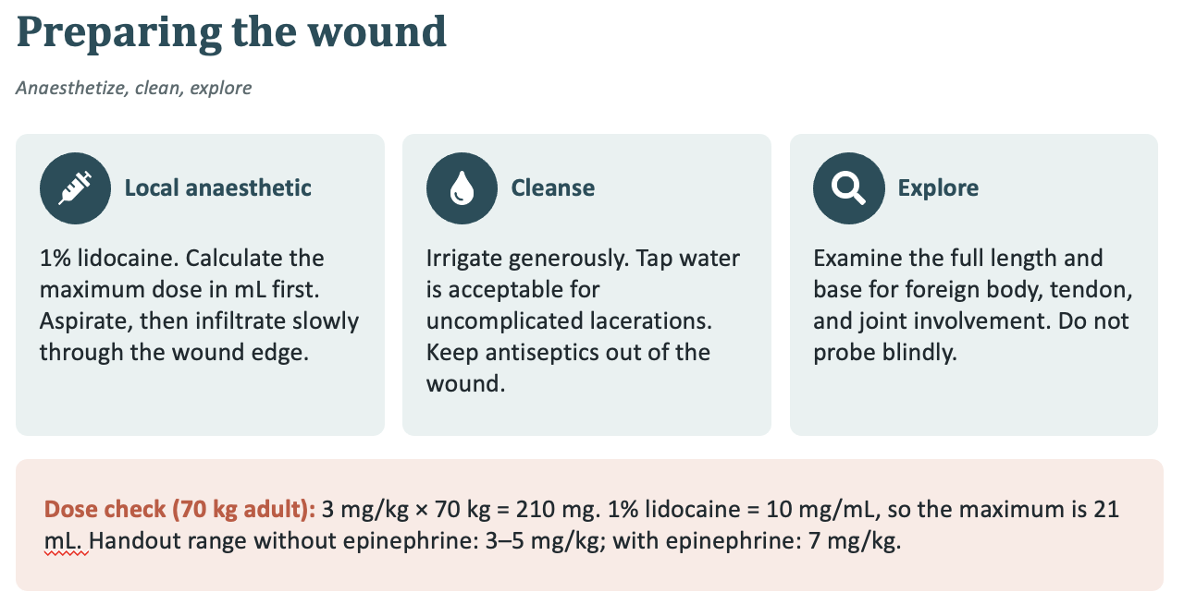
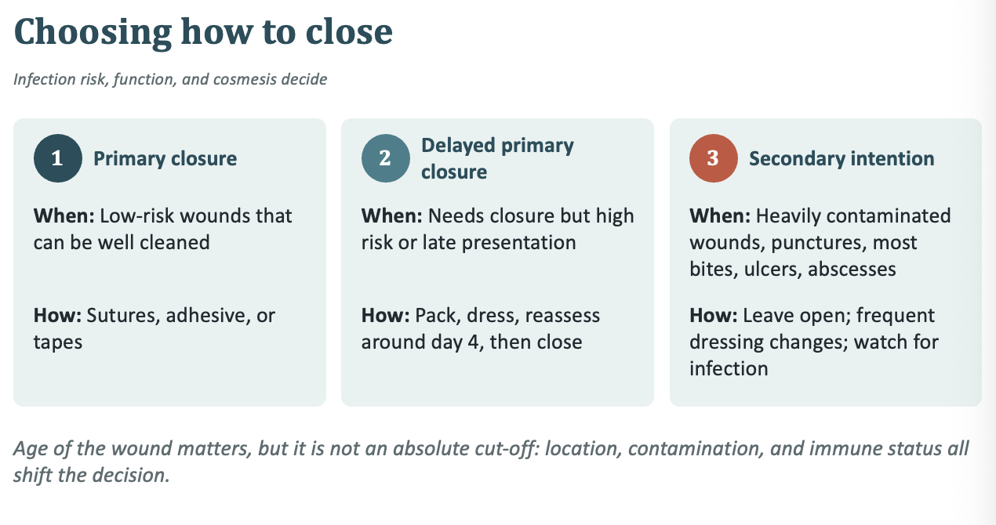
Handout timing guide for primary closure: under 6–8 hours in most sites, under 12–18 hours on face or scalp, under 4–6 hours on feet.
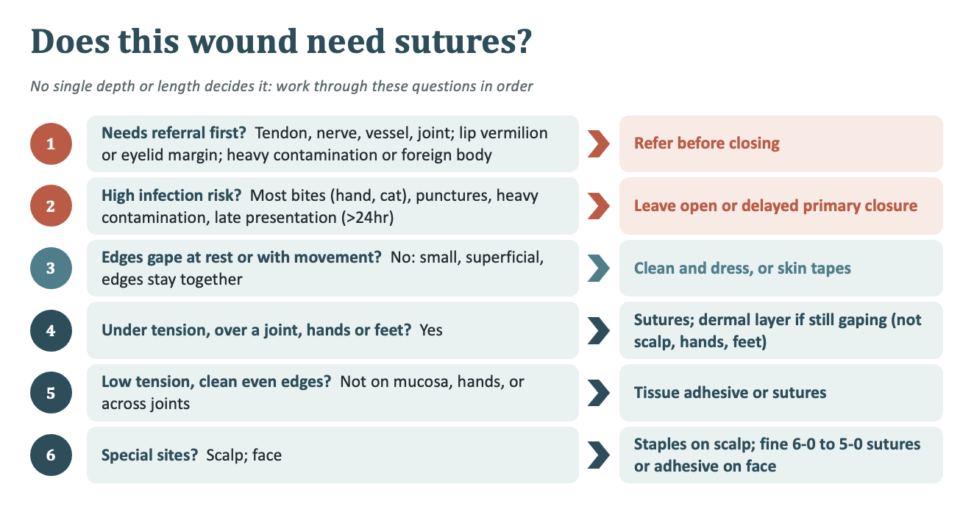
The practical test is whether the edges gape at rest or with movement, and whether the wound is under tension or in a functionally or cosmetically important area. Wounds older than 24 hours as a contraindication to repair. Treat wound age as one factor alongside location and contamination.

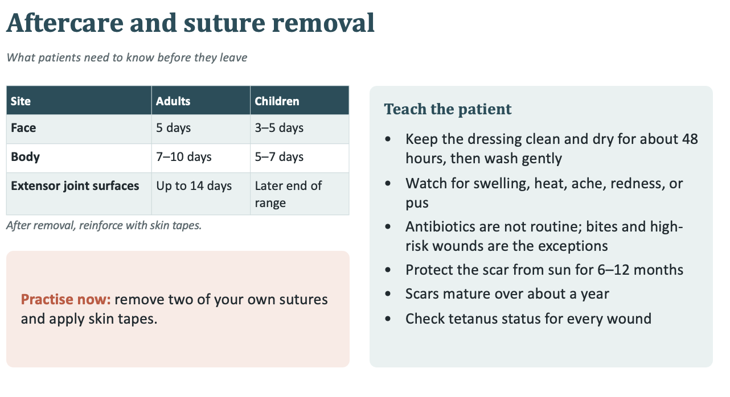

AFTER CARE IS IMPORTANT **
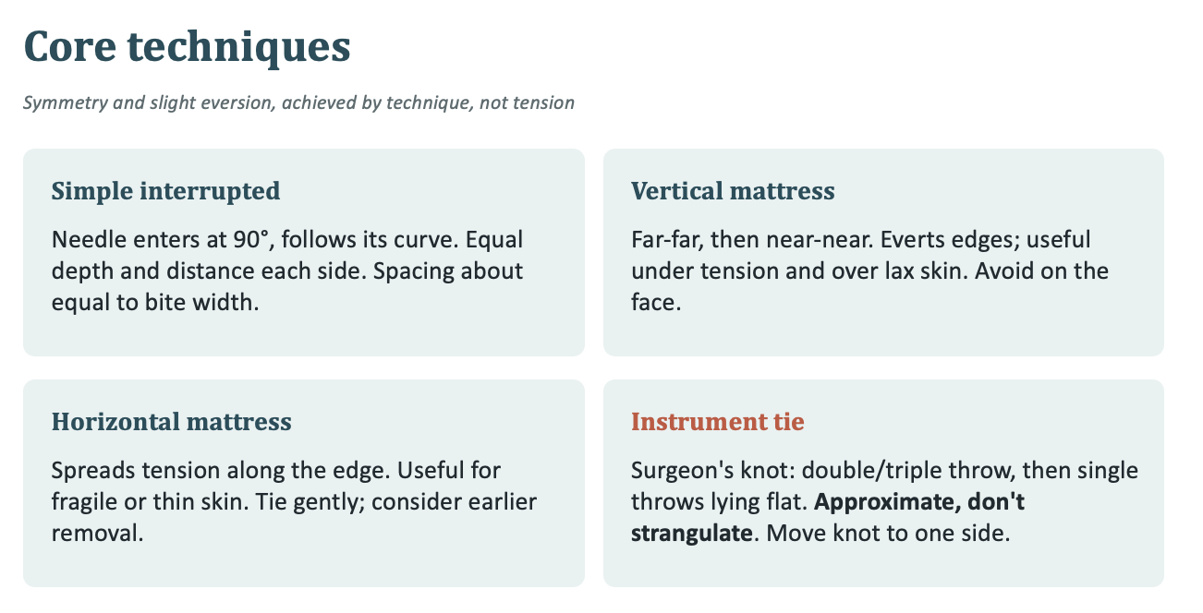
An instrument tie is a way of tying a suture knot using the needle holder instead of your fingers. After you pass the needle through both sides of the wound, you wrap the suture around the tip of the needle holder, then use the holder to grab the short end and pull it through the loop. It's the standard technique for skin closure because it's quick, uses little suture material, and keeps your fingers away from the needle.

- 4mm or less DONT have to suture **
Week 5
Melanonychia - normal darker nail lines usually in dark skin, under 3mm and on multiple nails, normal finding

SCC- non healing, crusted plaque

Venous ulcers- usually leg swelling
Arterial usually decreased pulses

melanoma - best to do excisional biopsy of whole lesion with narrow margins taken to full thickness

Punch biopsy
A, b, c, d

Suture
A, B, C, D (normally blanch with tie tightness)

Laceration
3.0 thicker than 6.0 thinner
Face 3-5days
B.
Staples for scalp

Bite
A, C, D

Cardiology
Priority
HTN
DYSLIPIDEMIA
PVD
Rheumatic fever
Heart failure *** will be on exam

A 54-year-old reports three weeks of fatigue and jaw discomfort on the stairs.
What is on your differential?
STEMI, NSTEMI, Angina, HF
Would your answer change with the person's sex?
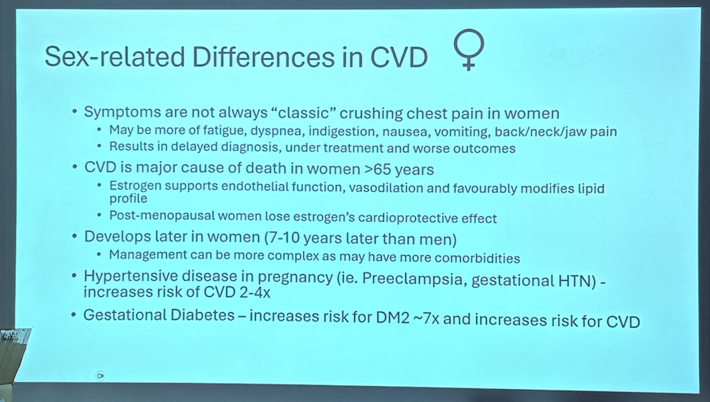

HTN
Gestational- ASA start before 16wks

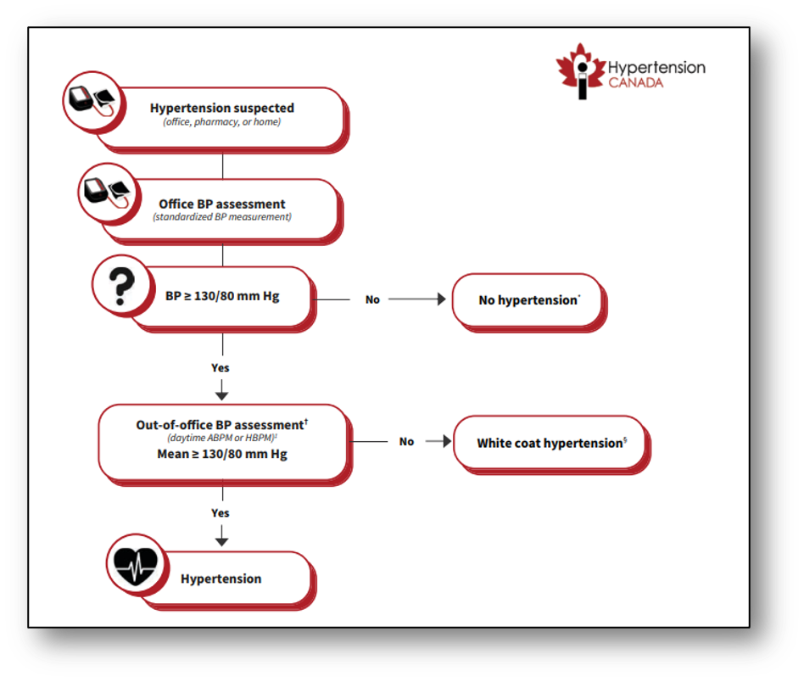
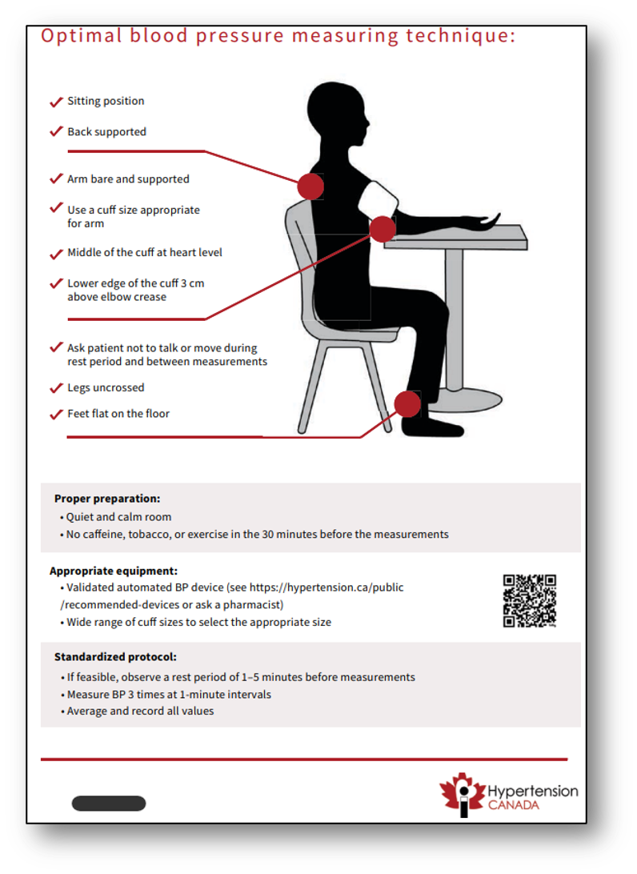
Guidelines were published in 2025 ** and Hypertension is no longer a BP >140/90

The guideline committee placed high value on early detection and intervention by defining hypertension at a lower threshold (BP 130/80 mm Hg) than in previous guidelines
For DIAGNOSIS 130/80, treatment may start at 140/90
- 3 BP above 130/80
- For 1 week the patient should test it morning and night
Out-of-office BP assessment is recommended to confirm the diagnosis of hypertension or to detect white-coat hypertension and masked hypertension (strong recommendation, moderate certainty evidence).
- measuring blood pressure at home is a better predictor of cardiovascular events than office-based readings
- Make sure the client is using proper technique & with good instructions (e.g. no caffeine, alcohol, smoking, heavy exercise immediately proceeding)
-24hr BP monitoring

- 3 readings at least 1 minute apart
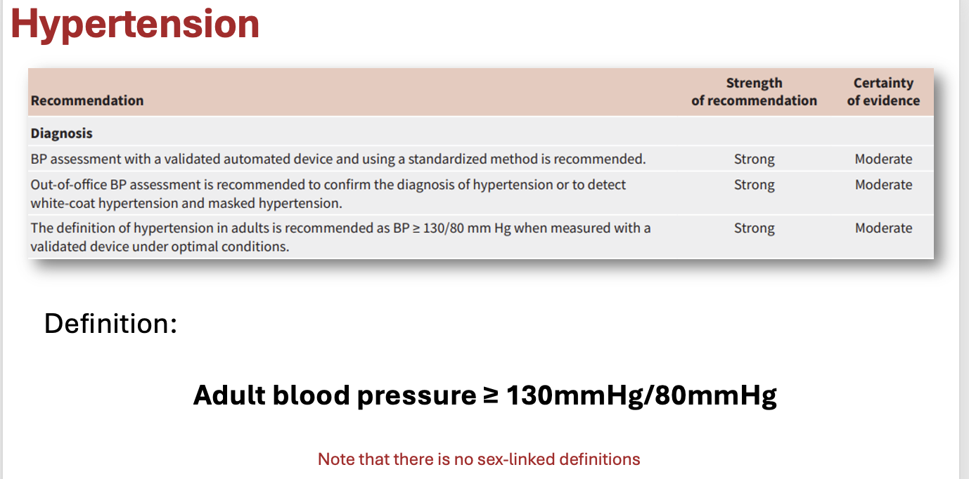
- AUTOMATED IS MORE ACCURATE** and check bp cuff size
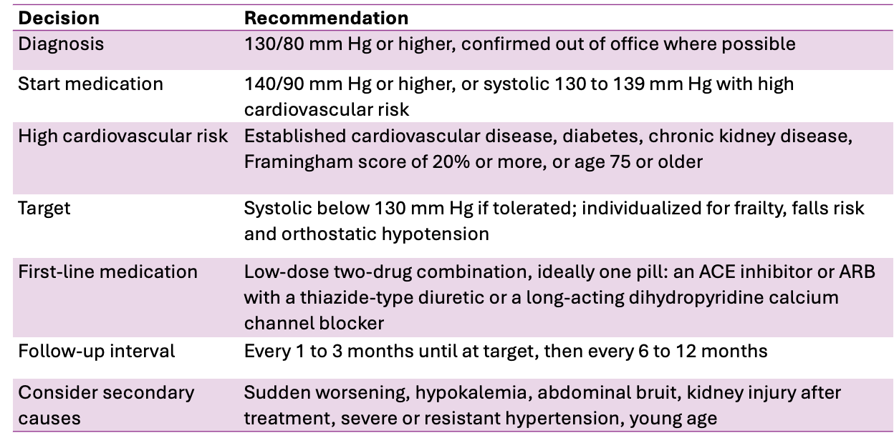

- Goals of care** may need a higher BP-- If theyre feel getting symptoms of low BP, if theyre frail for falls, or if theyre on multiple medications, additional risks of side effects
- Secondary causes** aneurysm=bruit, may need to see cardiology
- Metabolic disease
- Black and hispanic people tend to have higher BP at younger ages

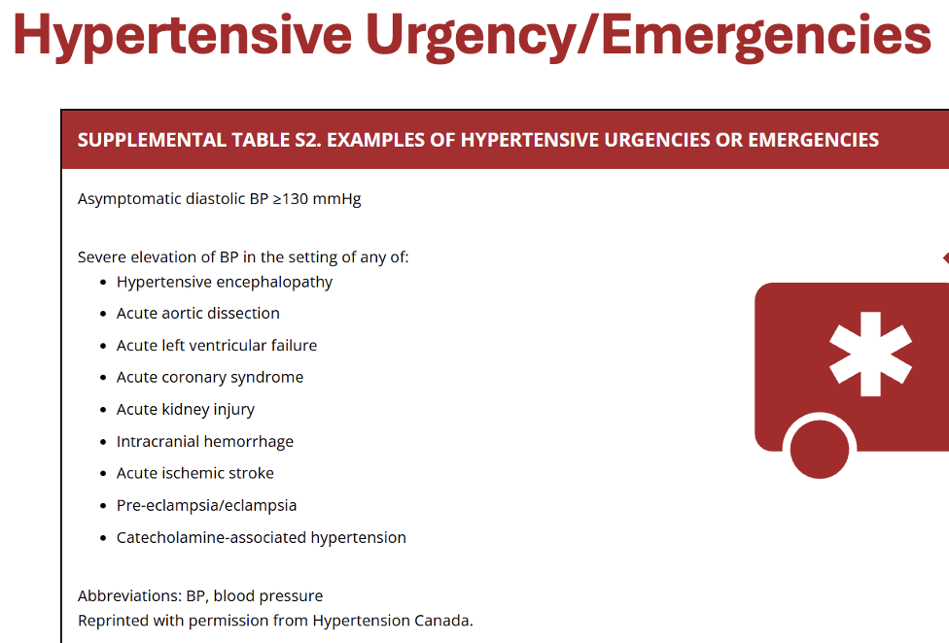
- DIASTOLIC BP >130 emergency
- Catecholamine-induced hypertension (HTN) is a dangerous spike in blood pressure caused by high levels of stress hormones like norepinephrine and epinephrine in the blood.
- Causes and Mechanism
• Main Triggers: It is often caused by rare tumors called pheochromocytomas and paragangliomas (PPGLs), which grow in the adrenal glands or nerve tissues and release massive amounts of hormones.
• The "Fight or Flight" Effect: Excess hormones overstimulate blood vessels and the heart, causing severe vasoconstriction (narrowing of blood vessels) and sudden, extreme blood pressure spikes.
• Crisis Level: This can lead to a hypertensive crisis where blood pressure climbs to 180/120 mm Hg or higher, risking heart attacks, strokes, or organ damage

Investigations
Recommendations
Routine tests that should be performed for the investigation of all patients with hypertension include the following:
- Urinalysis (Grade D);
  - Protein in urine, more pressure from HTN
- Blood chemistry (potassium, sodium, and creatinine; Grade D);
  - Diuretics, kidney function
- Fasting blood glucose and/or glycated hemoglobin (Grade D);

- Serum total cholesterol, low-density lipoprotein, high-density lipoprotein (HDL), and non-HDL choles-terol, and triglycerides (Grade D); lipids may be drawn fasting or nonfasting (Grade C); and
- Standard 12-lead electrocardiography (Grade C).

Grade D- expert informed

Additional Investigations
- Assess urinary albumin excretion in patients with diabetes (Grade D).
- All treated hypertensive patients should be monitored according to the current Diabetes Canada guidelines for the new appearance of diabetes (Grade B).
- During the maintenance phase of hypertension management, tests (including those for electrolytes, creatinine, fasting lipids, and pregnancy) should be repeated with a frequency reflecting the clinical situation (Grade D; revised recommendation).
- A pregnancy test should be considered before initiation of health behaviour management changes or drug therapy (Grade D; new recommendation).
- Routine echocardiographic evaluation of all hypertensive patients is not recommended (Grade D).
- An echocardiogram for assessment of left ventricular hypertrophy is useful in selected cases to help define the future risk of cardiovascular events (Grade C).
- Echocardiographic assessment of left ventricular mass, as well as of systolic and diastolic left ventricular function is recommended for hypertensive patients suspected to have left ventricular dysfunction or coronary artery disease (CAD; Grade D).
- Patients with hypertension and evidence of heart failure should have an objective assessment of left ventricular ejection fraction, either using echocardiogram or nuclear imaging (Grade D).

Follow up questions in OSCE**
- Will be asked differential diagnosis
- Lab values
- Educational reasoning
- Clinical reasoning

BMI
- Over weight 25-29
- Obese >29

Dyslipidemia
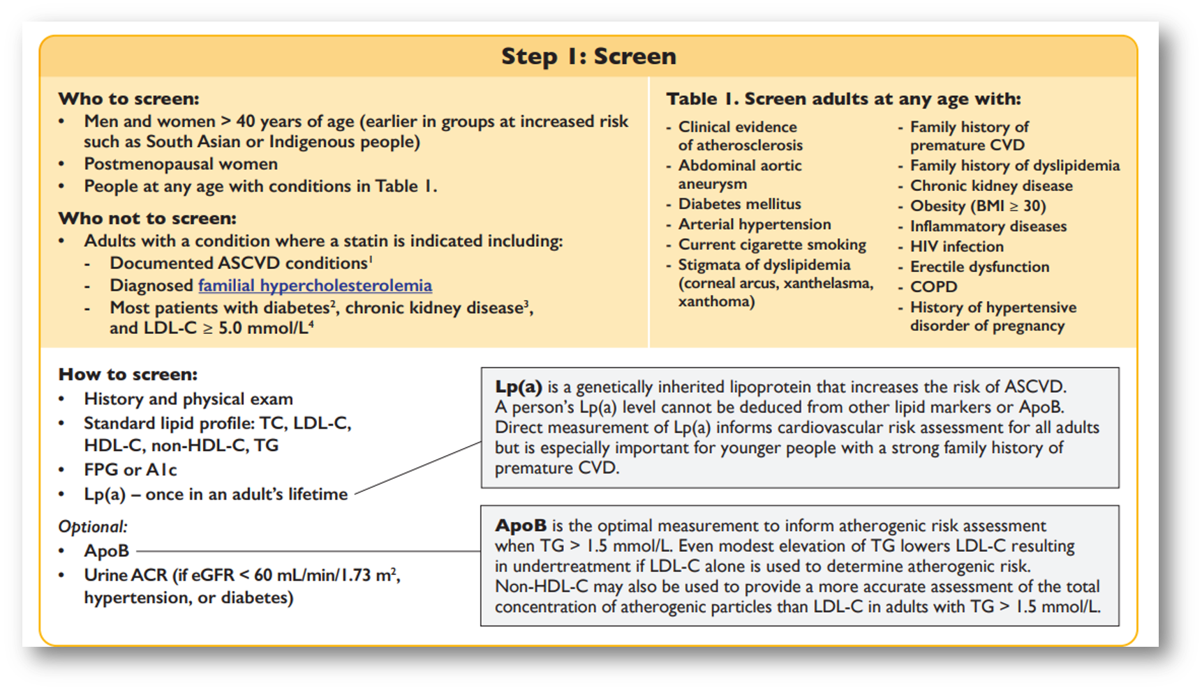

- Erectile dysfunction - blockages in the arteries to the penis**
- ASCVD atherloscelrosis cardiovascular disease
- Apolipide A- important for family hx , and familiar hypercholest.
- ApoB- when TRIGLYCERIDE is over >1.5, atherogenic risk assessment
- FPG fasting PLASMA glucose

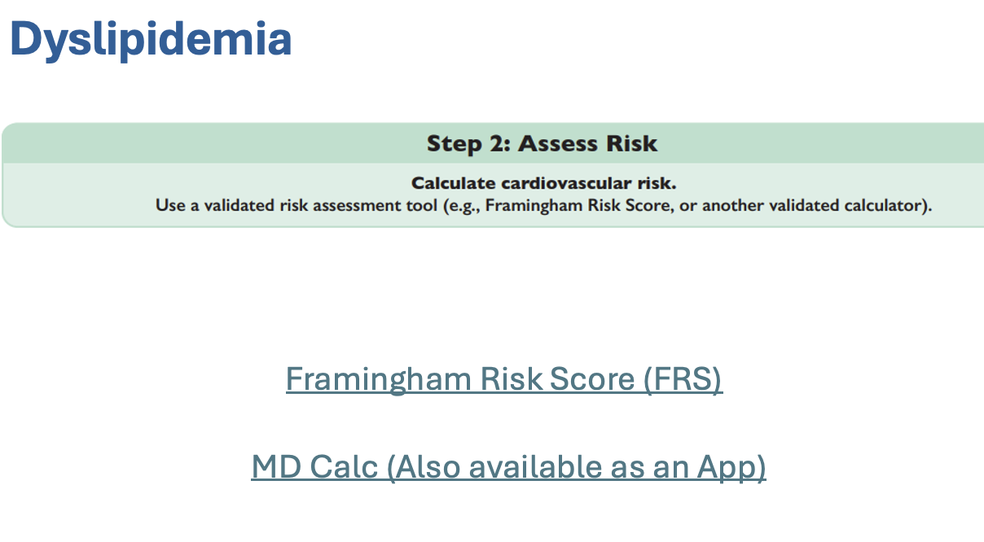
What factors does
HDL and total
Systolic BP and if its treated
diabetes and smoking
Early CVD in 1st degree relatives** m <55 f<62
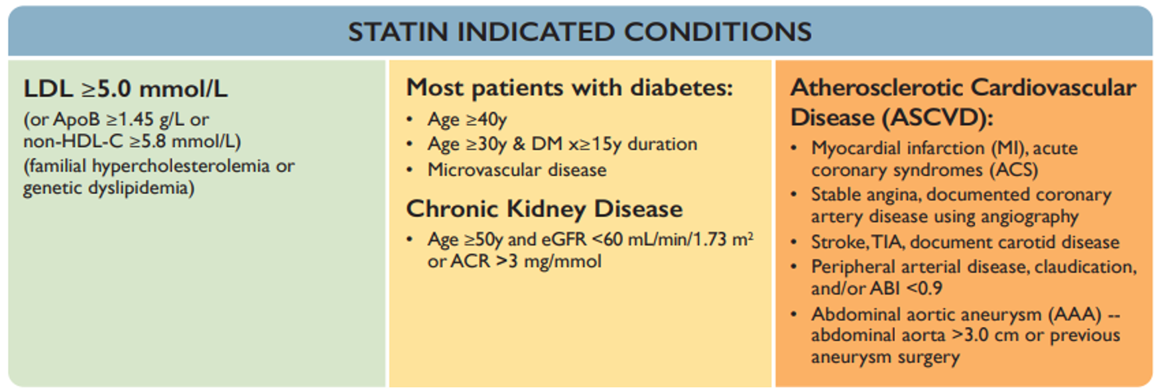
-statins are recommended for dyslipidemia, not always tolerated with other agents
-statins can cause rhabdo

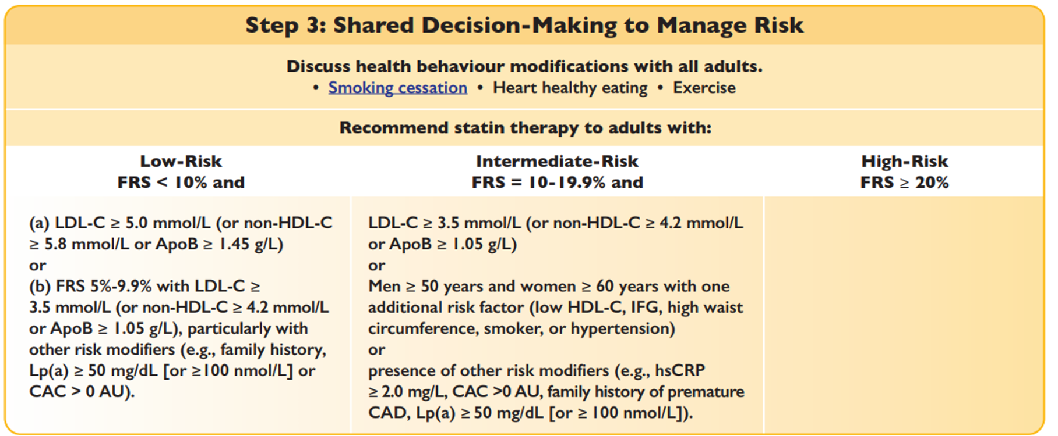

ALWAYS smoking cessation, healthy heart eating, exercise

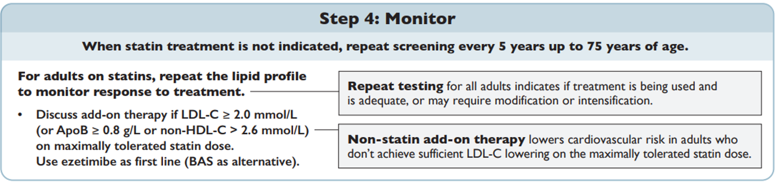
- usually try 3 months with lifestyle and medications, repeat until managed
- 5 years if not on statin
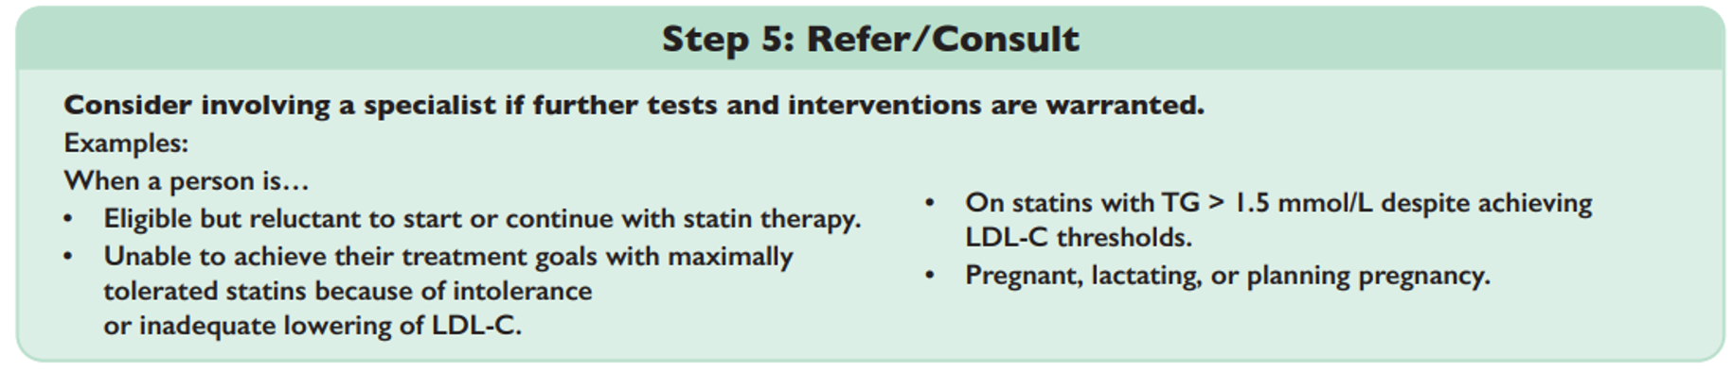

PAD
Leg symptoms: arterial or venous?

How peripheral arterial disease and venous insufficiency are diagnosed, how they present, how they are tested, and which findings are red flags

PAD ABI < 0.9
- suggests PAD. In people with symptoms, the diagnosis is confirmed with an ankle-brachial index and/or a toe-brachial index.

Venous Insuff Reflux > 0.5 s
- in superficial veins on duplex ultrasound (more than 1 s in the femoral or popliteal veins), alongside clinical signs classed C0 to C6.

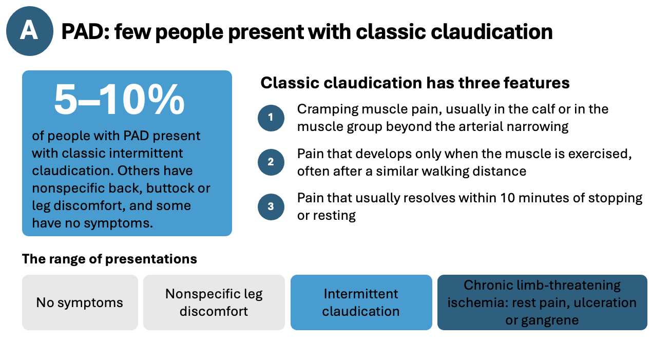
- Classic claudication 3 features **
- When muscle is being USED**
- Pain resolves** within 10 min
- Limb threatening- PAIN DOES NOT GO AWAY**

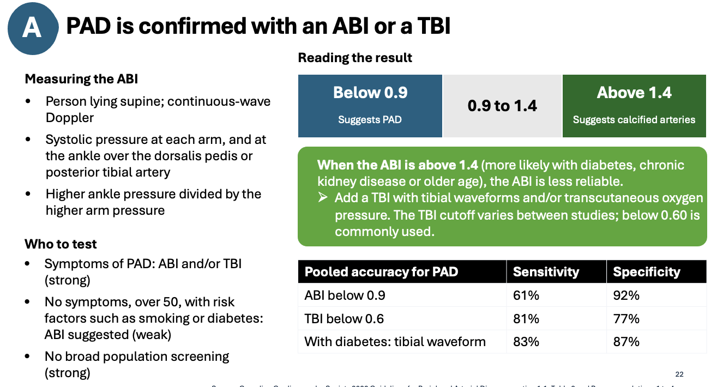

** BELOW 0.9 PAD*
Above 1.4- abi is less reliable, suggests Calcified arteries
- Women have more asymptomatic and weird symptoms
- 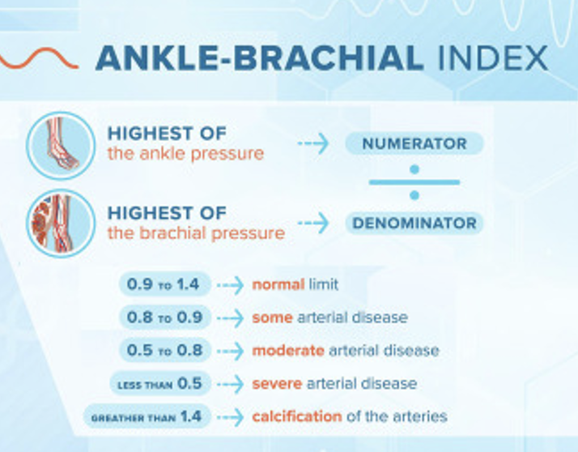
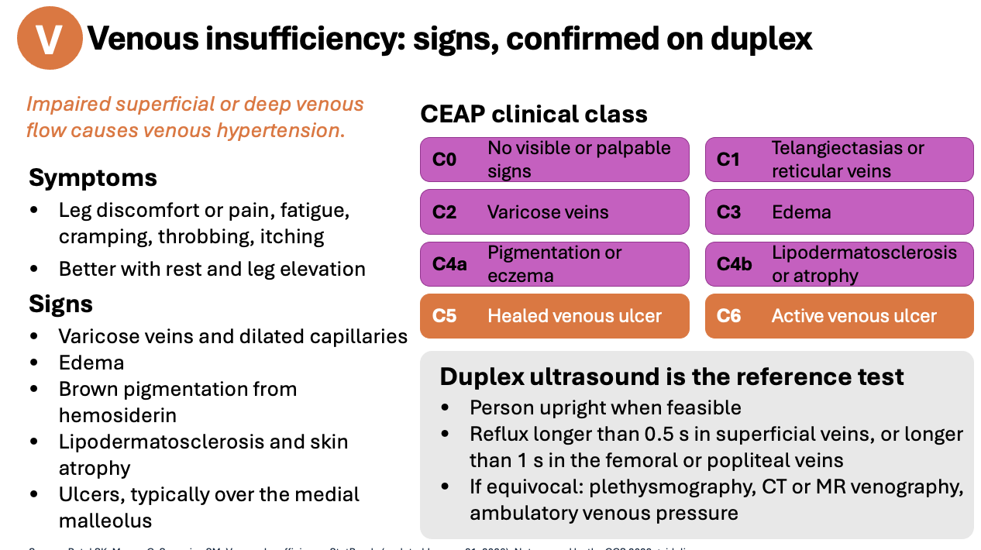
The clinical classes-- Nice to know, not a required reading
- Should know the ulcers descriptions, signs/sympt

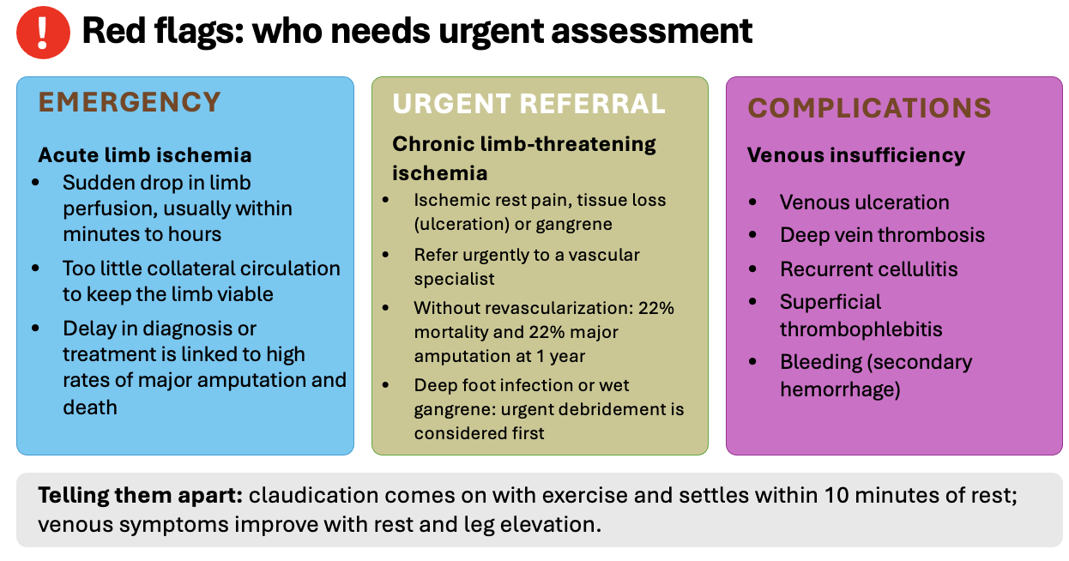
- Complication red flags DVT** cellulitis

- ** que length of time it settles and when

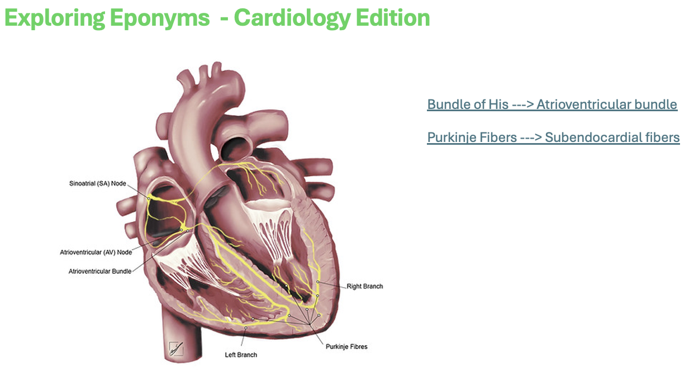
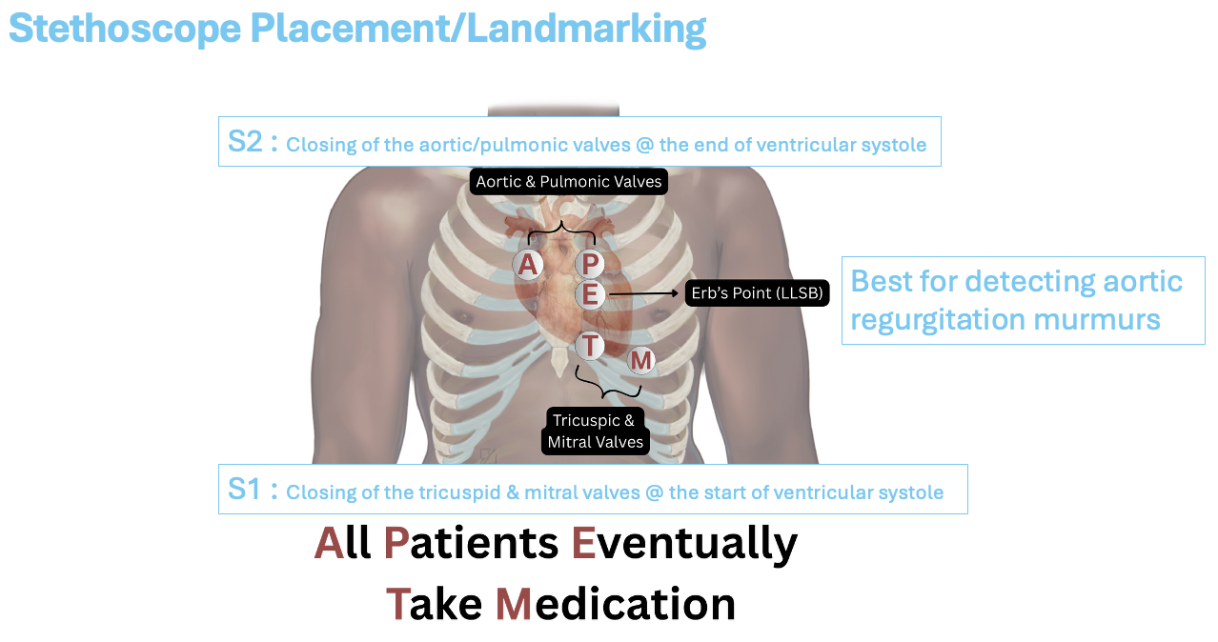

Heart Murmurs
- Grading how loud the murmur is
- Systolic murmurs- opening of the tricuspid and mitral valves
- diastolic murmurs

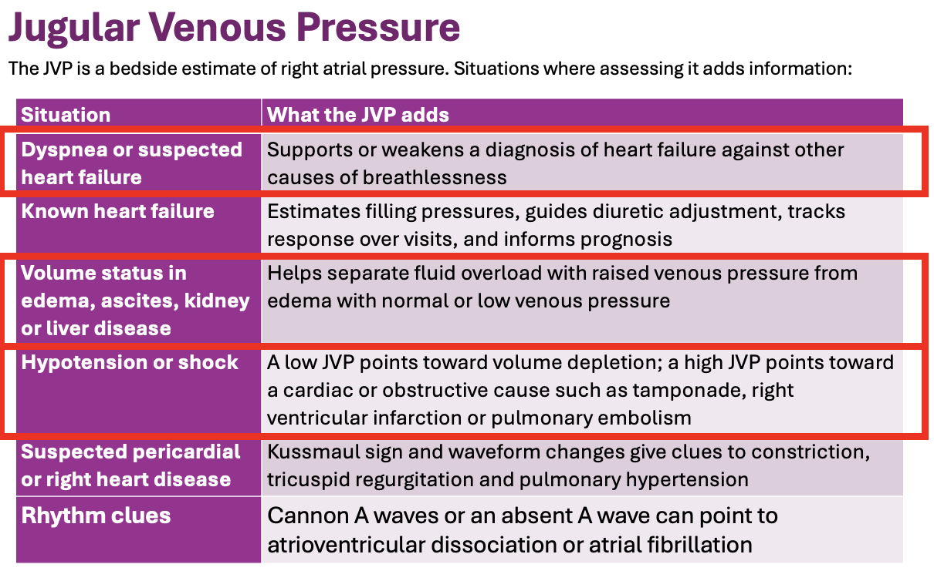
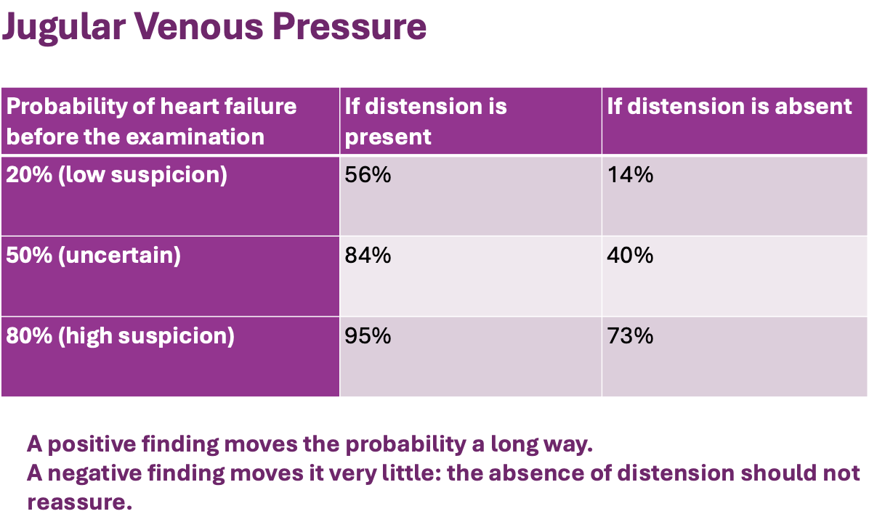

- Looking at OVERLOAD
- Get the patient to relax, raise the bed so you are not straining. 30-45 degrees*
  - Not accurate supine
- Take the pillow away; the waveforms are often better seen with the head lying directly against the examining table/bed.
- Position the neck until you have the best view.
- If you make sure the room is well lit, there is no need for shining a flashlight, penlight or other direct light.
- Make your first goal just to see a pulsation, and then decide if it is arterial or venous by applying the following criteria to identify venous waves:
  - Venous wave is bifid, flicking like a snake's tongue.
  - It rises when you lower the head of the bed and sinks when you raise the head of the bed.
  - It changes with respiration, sinking into the chest with inspiration.
  - It is not palpable.
    - It is fine to use the external jugular vein, as long as you can see clear wave forms in it.
  - Commonly, a prominent pulsation is mistaken for that of the carotid artery rather than of the JVP. To differentiate, press on the RUQ while watching the neck. The JVP should rise in all individuals with this maneuver; whereas a carotid pulsation should not change.
- The JVP can be assessed on either the right or left. On occasion (musculoskeletal anatomy, venous clots) the pulsations can only be visualized on one side. If you cannot clearly define the JVP on the right internal jugular, examine the left.
- If you cannot determine the JVP, report the exam as "JVP not visualized" rather than "no JVD" (which implies that the JVP was visualized and is not elevated)

- Can use external jugular, can apply pressure
- Dont have them flat*** will increase pressures
- Normal is less than 3** mmhg
- If you put pressure on their abdomen aorta assess, may increase which would show fluid - avoid if abdo pain or known AAA
- Congestive heart failure- dyspnea and edema
- Extra fluid in the atrium **
- Echo would be the next step***

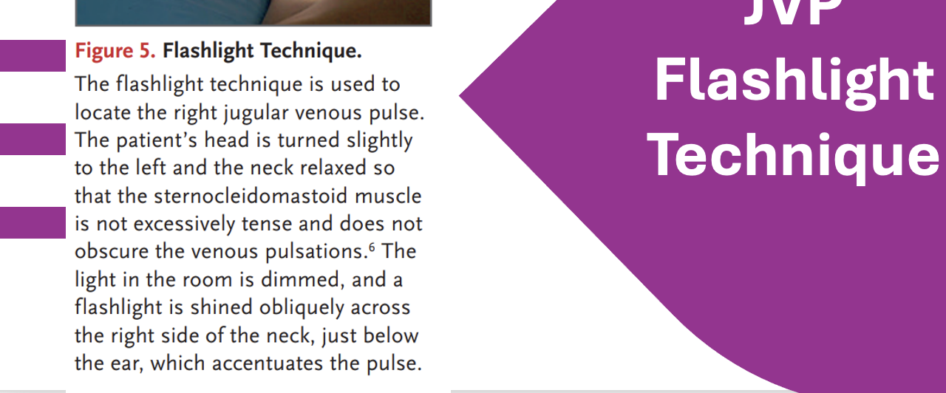

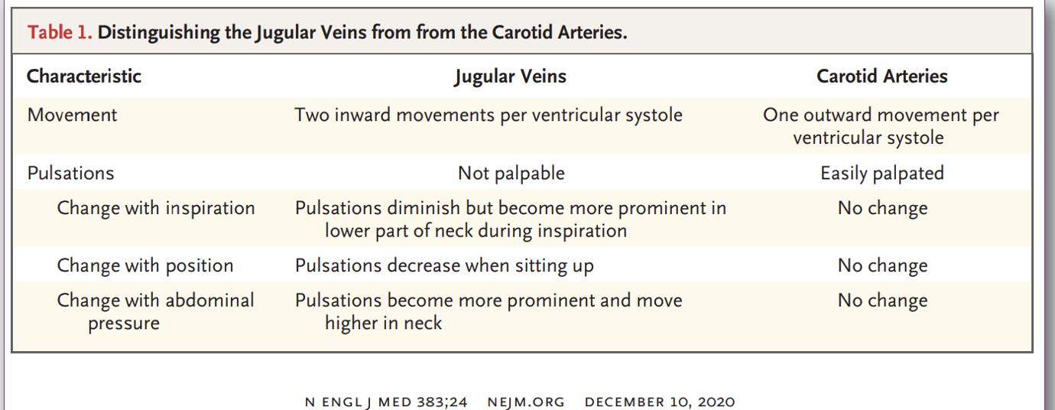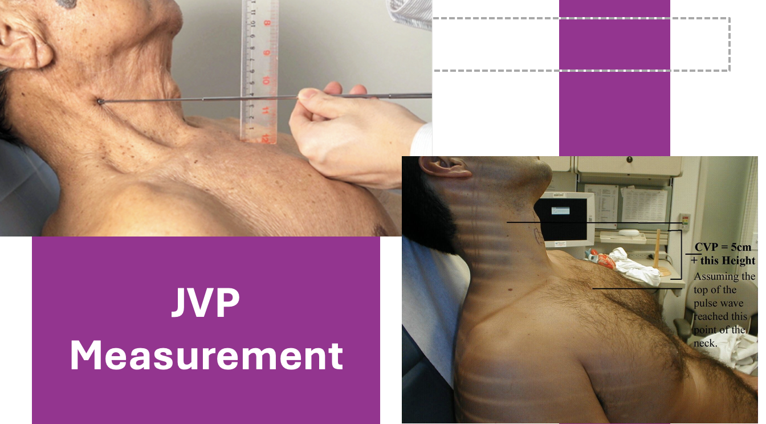
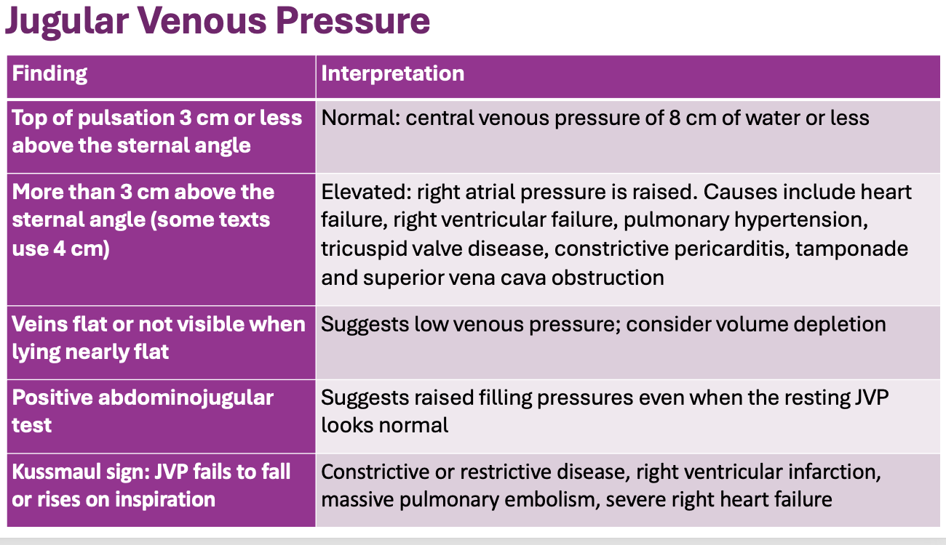
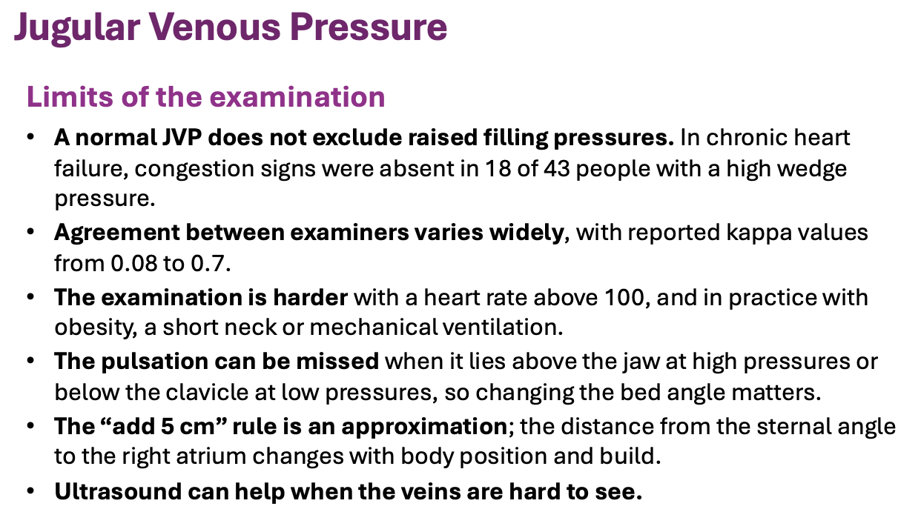

Cardiovascular Assessment & Therapeutics
AHAD + THERA | Study Notes

1. DYSLIPIDEMIA

Screening and Risk Assessment
Population | Screening
Adults ≥40 years | Routine lipid screening
High-risk populations | Consider earlier screening
South Asian and Indigenous populations | Earlier risk assessment may be indicated
Postmenopausal individuals | Consider increased cardiovascular risk
Investigations
- Lipid profile (LDL-C, HDL-C, total cholesterol, triglycerides)
- Lipoprotein(a)
- Framingham Risk Score (FRS)
- Assess secondary causes, including hypothyroidism

Framingham Risk Score (FRS)
Estimates 10-year cardiovascular risk to guide treatment.
Risk | 10-Year Risk | Management
Low | <10% | Lifestyle modifications
Intermediate | 10–19.9% | Shared decision-making; consider statin
High | ≥20% | Statin therapy generally indicated
Risk factors: Age, smoking, cholesterol, systolic BP and family history. Diabetes and established cardiovascular disease are important considerations when deciding whether FRS calculation is appropriate.
Conditions that may warrant statin treatment without FRS calculation:
- Established atherosclerotic cardiovascular disease (ASCVD)
- Familial hypercholesterolemia
- LDL-C ≥5.0 mmol/L
- Diabetes or chronic kidney disease (depending on specific criteria)
EXAM TIP: Know risk categories, statin indications and when FRS is not required.

Treatment (THERA)
First-line: Statins when indicated.
Nonpharmacological
- Smoking cessation
- Regular physical activity
- Healthy diet
- Weight management
Monitoring
- Repeat lipid profile approximately 3 months after treatment or lifestyle changes, as discussed in lecture.
- Assess effectiveness, adherence and adverse effects.
- Consider dose adjustments or alternative treatment if targets are not achieved.

Statin-Associated Muscle Symptoms
Symptoms: Myalgia, weakness, muscle tenderness.
Consider secondary causes:
- Strenuous exercise
- Hypothyroidism
- Vitamin D deficiency
- Drug interactions
Management
- Assess symptom severity and timing.
- Consider creatine kinase (CK) testing when indicated.
- Adjust dose or switch statins if appropriate.
- Consider non-statin treatment if necessary.
RED FLAG: Severe muscle pain or weakness with dark urine → possible rhabdomyolysis; urgent assessment.

Clinical Case: Elevated LDL + Elevated TSH
- Elevated TSH may indicate hypothyroidism.
- Hypothyroidism can increase cholesterol levels and contribute to statin-associated muscle symptoms.
- Assess and treat thyroid dysfunction.
- Reassess lipid levels and cardiovascular risk.
- Statin therapy may still be necessary depending on cardiovascular risk.

2. PERIPHERAL ARTERY DISEASE (PAD) VS. CHRONIC VENOUS INSUFFICIENCY (CVI)

Key Differences
Feature | PAD (Arterial) | CVI (Venous)
Pain | Exertional pain, relieved by rest | Aching, heaviness, throbbing
Location | Commonly calves | Lower legs
Leg elevation | May worsen ischemic pain | Usually improves symptoms
Skin | May be cool, pale | Brown pigmentation
Pulses | May be reduced or absent | Often preserved
Other findings | Intermittent claudication | Edema, varicose veins, itching
Main test | Ankle-brachial index (ABI) | Venous duplex ultrasound

PAD: Classic Presentation
Intermittent claudication
- Calf pain or discomfort during walking/exercise.
- Relieved by rest.
- Caused by insufficient arterial blood flow during exertion.
Diagnostic test: ABI
- ABI <0.90 supports PAD diagnosis.
- ABI may be falsely elevated in patients with noncompressible arteries.
Assessment questions
- Does pain begin with walking?
- How far can you walk before symptoms begin?
- Does pain resolve when you stop?
- Is there pain at rest?
- Any nonhealing wounds?

Chronic Venous Insufficiency
Symptoms
- Leg heaviness or fatigue
- Aching, cramping or throbbing
- Itching
- Edema
- Varicose veins
- Brown skin pigmentation
Characteristic finding: Symptoms often improve with leg elevation.
Investigation: Duplex ultrasound.
Diagnostic finding: Superficial venous reflux >0.5 seconds.

Vascular Red Flags
Acute Limb Ischemia: 6 Ps
- Pain
- Pallor
- Pulselessness
- Paresthesia
- Paralysis
- Poikilothermia (cold limb)
Urgent vascular assessment required.
Chronic Limb-Threatening Ischemia
- Ischemic rest pain
- Nonhealing ulcers
- Gangrene
EXAM TIP: Exertional calf pain relieved by rest = PAD. Aching and swelling improved by elevation = venous insufficiency.

3. CARDIAC AUSCULTATION

Valve Locations
Valve/Area | Location
Aortic | 2nd intercostal space (ICS), right sternal border
Pulmonic | 2nd ICS, left sternal border
Erb's point | 3rd ICS, left sternal border
Tricuspid | 4th–5th ICS, left lower sternal border
Mitral | 5th ICS, left midclavicular line
Mnemonic: All People Enjoy Time Magazine.

Stethoscope
Diaphragm | Bell
High-pitched sounds | Low-pitched sounds
S1/S2 | S3/S4
Many murmurs | Some low-pitched murmurs
Technique: Use light pressure with a traditional bell. Excess pressure can make it function like a diaphragm.

Heart Murmurs
Grade I–VI
- I: Very faint
- II: Soft, easily heard
- III: Moderately loud
- IV: Loud, palpable thrill
- V: Very loud, heard with stethoscope partially off chest
- VI: Heard without full contact
Key points
- Systolic murmurs are more common than diastolic murmurs.
- Document timing, location, intensity, radiation and associated findings.
- Diastolic murmurs are generally pathological and warrant evaluation.

4. JUGULAR VENOUS PRESSURE (JVP)

Purpose
JVP estimates right atrial pressure and assists in assessing fluid status.
Clinical uses
- Suspected heart failure
- Fluid overload
- Elevated right-sided cardiac filling pressures
Important: An elevated JVP supports congestion. A normal JVP does not exclude heart failure.

Assessment Technique
- Position patient at approximately 45°.
- Turn head slightly away from the right side.
- Inspect the right neck for internal jugular venous pulsations.
- Identify the highest point of venous pulsation.
- Measure vertical height above the sternal angle using a ruler.
Lecture cutoff: JVP >3 cm above the sternal angle was considered elevated.

JVP vs. Carotid Pulse
Feature | Jugular Venous Pulse | Carotid Pulse
Palpable | No | Yes
Waveform | Multiple components | Single outward pulsation
Position changes | Yes | Minimal change
Abdominal pressure | May increase | No significant change
EXAM TIP: JVP is nonpalpable and changes with position.

Abdominojugular Reflux (AJR)
Purpose: Assesses the ability of the right heart to accommodate increased venous return.
Technique
- Position patient for JVP assessment.
- Apply firm, sustained abdominal pressure for approximately 10 seconds.
- Observe JVP response.
Positive finding: Sustained JVP increase >4 cm H₂O (lecture threshold).
Interpretation: Suggests elevated right atrial pressure or right-sided cardiac dysfunction.

JVP Waveforms
Wave | Significance
A | Right atrial contraction
C | Tricuspid valve bulging in early systole
X descent | Atrial relaxation/downward tricuspid movement
V | Right atrial filling
Y descent | Right atrial emptying into right ventricle
Clinical focus: Prioritize distinguishing JVP from carotid pulsations, correct measurement technique and recognition of an elevated JVP.

5. CLINICAL ASSESSMENT AND FOLLOW-UP

Dyslipidemia: Clinical Approach
Subjective
- Previous cardiovascular disease?
- Diabetes, CKD or thyroid disease?
- Smoking history?
- Family history of premature cardiovascular disease?
- Current medications?
- Previous statin use or adverse effects?
- Diet and exercise habits?
Objective / Investigations
- BP and cardiovascular examination
- Lipid profile
- Assess secondary causes
- Calculate FRS when appropriate
Plan
- Determine cardiovascular risk.
- Discuss lifestyle changes.
- Start or optimize statin when indicated.
- Shared decision-making.
- Arrange lipid monitoring and follow-up.

PAD / Venous Insufficiency: Clinical Approach
Subjective
- Pain with walking or at rest?
- Relief with rest versus elevation?
- Leg swelling?
- Skin changes or ulcers?
- Smoking, diabetes or cardiovascular history?
Objective
- Peripheral pulses
- Skin colour and temperature
- Edema
- Varicosities
- Ulcers or tissue damage
Investigations
- PAD → ABI
- CVI → Venous duplex ultrasound
Red flags
- Sudden painful, cold or pulseless limb
- New neurological deficits in affected limb
- Ischemic rest pain, gangrene or nonhealing wounds

6. HIGH-YIELD EXAM REVIEW
Finding / Question | Key Answer
FRS low risk | <10%
FRS intermediate risk | 10–19.9%
FRS high risk | ≥20%
Markedly elevated LDL-C | ≥5.0 mmol/L
PAD diagnostic ABI | <0.90
Superficial venous reflux | >0.5 seconds
PAD hallmark symptom | Intermittent claudication
CVI hallmark symptoms | Heaviness, edema, improvement with elevation
JVP position | Approximately 45°
Elevated JVP (lecture) | >3 cm above sternal angle
Positive AJR (lecture) | Sustained rise >4 cm H₂O
JVP vs carotid | JVP is nonpalpable
Severe statin muscle symptoms | Assess for myopathy/rhabdomyolysis
Elevated TSH + high LDL | Consider hypothyroidism as secondary cause
Diaphragm | High-pitched heart sounds
Bell | Low-pitched heart sounds

Items to Verify Against Course Guidelines
- Exact FRS variables and definition of premature family history.
- Diabetes/CKD statin eligibility criteria.
- Recommended lipid screening and monitoring intervals.
- Referral thresholds for hypertriglyceridemia.
- JVP and AJR thresholds, which vary across clinical references.
Study priority: Focus on differentiating PAD from CVI, interpreting ABI, recognizing urgent vascular presentations, determining dyslipidemia risk and treatment, and performing JVP assessment correctly.

